# MAJOR PROJECT ON

# Online EXAMINATION PORTAL

# SUBMITTED BY:

Rishav Shah (14501217030)[tiit].

Argha mondal (14501217052)[tiit].

Ankita dey (14501217054)[tiit].

Pratima Ray (32001217012)[smit].

Santosh Chourasia (32001217007)[smit].

Avilash Jha (32001217012)[smit].

**In partial fulfilment for the award of the degree of**

**BACHELORS OF COMPUTER APPLICATION**

Under the guidance of

**PROF. ARINDAM RAY**

**COLLEGE NAME:**

**TECHNO INDIA INSTITUTE OF TECHNOLOGY**

**&**

**SAROJ MOHAN INSTITUTE OF TECHNOLOGY**

  

**Plot No J1-7, EP-Block, Sector V, Salt Lake, Electronics Complex**

**West Bengal 700091**

**YEAR-2017-2020**

Techno India Institute of Technology

#### (Maulana Abul Kalam Azad University of Technology (MAKAUT))

**FACULTY OF BCA DEPARTMENT**

**Certificate of Recommendation**

**This is to certify that the students have completed their project work titled “MAJOR PROJECT on: ONLINE EXAMINATION PORTAL” using PHP and MYSQL under the direct supervision and guidance of Prof. ARINDAM ROY.**

**We are satisfied with their work, which is being presented for the partial fulfilment of the degree of BACHELOR OF COMPUTER APPLICATION (BCA), Maulana Abul Kalam Azad University of Technology(MAKAUT), Kolkata – 700032.**

**_______________________**

**(ARINDAM RAY)**

**DATE:**

**  
 _______________________**

**(Raghunath Manna)**

**HOD BCA DEPARTMENT**

(TECHNO INDIA INSTITUTE OF TECHNOLOGY)

**MAULANA ABUL KALAM AZAD UNIVERSITY**

**OF TECHNOLOGY(MAKAUT),**

**FACULTY OF BCA DEPARTMENT**

**CERTIFICATE OF APPROVAL**

**The foregoing Major project is hereby approved as a creditable study of Bachelor of Computer Application (BCA) and presented in a manner satisfactory to warrant its acceptance as a pre-requisite to the degree for which it has been submitted. It is understood that by this approval the undersigned do not necessarily endorse or any statement made, opinion expressed or conclusion therein but approve this Major project only for the purpose for which it is submitted.**

**Signature of the Examiners:**

**_________________________________**

**_________________________________**

**_________________________________**

**PREFACE**

**The “PLANET EXAMINATIONS” is an online Examination portal project to automate all kinds of activity in the exams. The project aims in giving online exam and reduces effort save time and also gets to know the correct answer after giving the exam. This Examination portal has the feature of user login and admin login. Through the admin login the admin can monitor the whole system, and can maintain the portal. The admin can add or remove tests available in the system. It can also manage the timer present in. This is an alternative to the physical examinations, an online examination portal. The students after giving the test can see the scores and the answers which will help them improve their knowledge and weak areas. An online portal where users with unique id and password can login to the website.**

**Overall this project provides the facility to the students of the schools and colleges to test themselves and also have the opportunity to give exams for the selection of different MNCs.**

**Organization of the project:**

**Our team is a small group of 6 members. We are an organic type organisation team.**



**Online EXAMINATION PORTAL**

**Table of contents**

**1.acknowlegement**

**2.project aims and objectives**

**3.software specification**

**4. hardware cpu**

**5.software running environment**

**6.Designs and modules**

**7. coding standards and assumptions**

**8. testing**

**9.future scope**

**10. conclusion**

**11.bibliography**

** 1,Acknowledgment**

**We would like to take this opportunity to express our special thanks of gratitude to our project mentor, prof. ARINDAM ROY for his constant guidance and support in completing this project and Techno India for providing us a platform .we are also thankful to ANUP SIR, SUBHARANJAN SIR AND all the other faculty members for their fruitful advice ,support, attention and time.**

**Special thanks to all our group members and the team leader for their constant hard work in fulfilling the project aims and objectives.**











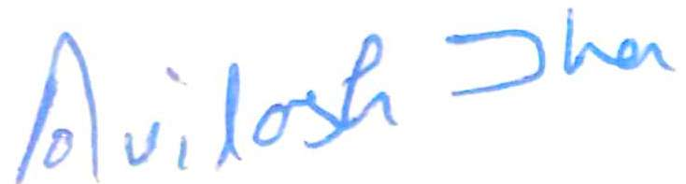



**2, Project aims and objectives**

**The aims and objectives that will be achieved after the completion of this project are as follows: -**

* **Students and job seekers giving online examination.**
* **User signup.**
* **Login page for existing users.**
* **Admin login page where the admin can add new subjects or remove old patterned exams .**
* **A search column for the user to search for the desired subject.**
* **Each exam of that particular subjects consists of MCQs which they have to give after a instruction message appear on the screen.**
* **Contact details for contacting in case of emergency.**
* **The answers will be submitted after they click finally submit button and then the user can get their result.**

**3. Software specification**

**3.1 Xampp: The Xampp web server is used for the testing and running the project.**

**3.2 Operating System: Windows 7 and 10 is used as the operating system as it is stable and user friendly.**

**3.3 Sublime Text: Sublime text is a clean, functional and fast code editor which supports plugins, snippets and many other things.**

**3.4 CodeIgniter(MVC FRAMEWORK):** **CodeIgniter is a powerful PHP framework with a very small footprint, built for developers who need a simple and elegant toolkit to create full-featured web applications**

**4. Hardware specification**

**4.1 1 GB RAM:RAM 1 GB is used which will provide faster reading and writing capabilities will in turn support faster processing.**

**4.2 Hard Disk Drive 40 GB: HDD 40 GB is used for storing and retrieving of large amount of data.**

**5. software running environment**

**5.1 Operating system:**

* **Windows 7 onwards**
* **Linux (workstation)**

**5.2. Browser specification:**

* **Internet Explorer 8 onwards**
* **Google Chrome**
* **Firefox**

**\*All the browsers need to be compatible with HTML 5.**



**6. Designs and modules**

* **FLOWCHART**

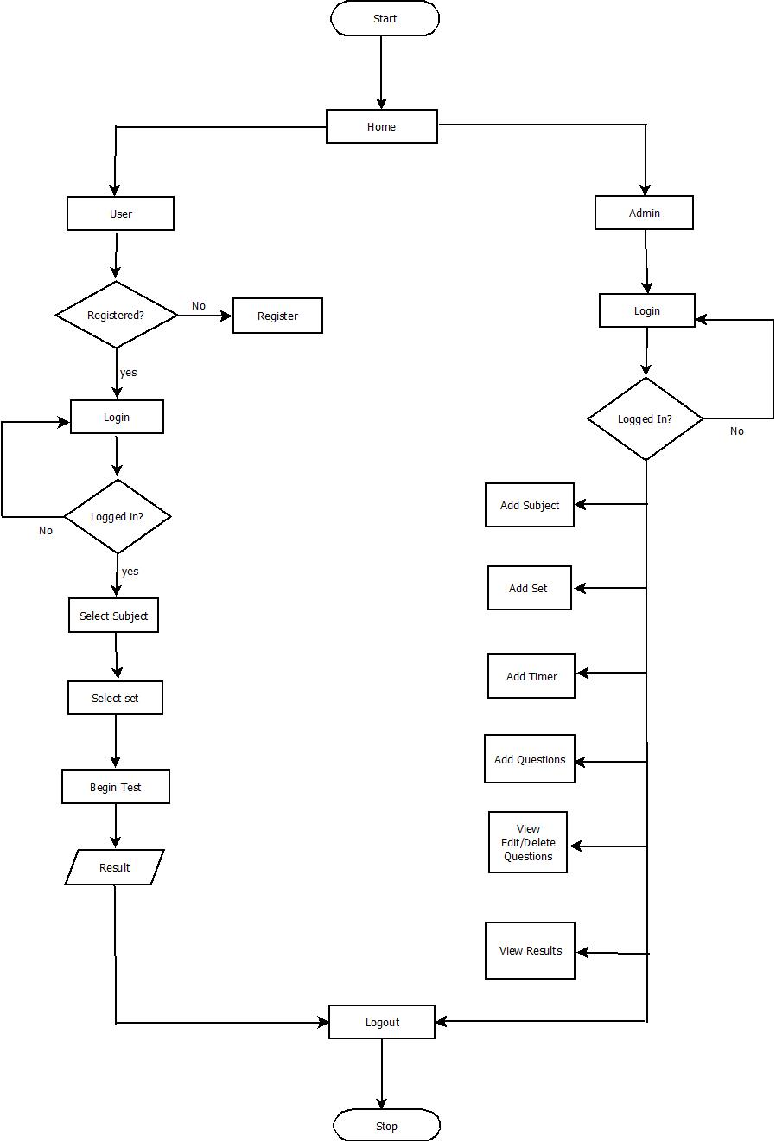

* **ENTITY RELATIONSHIP DIAGRAM**

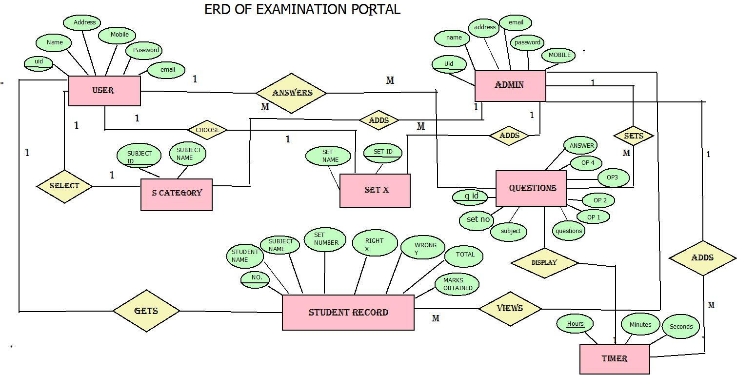

* **DATA FLOW DIAGRAM**

**LEVEL 0(Context Level):**

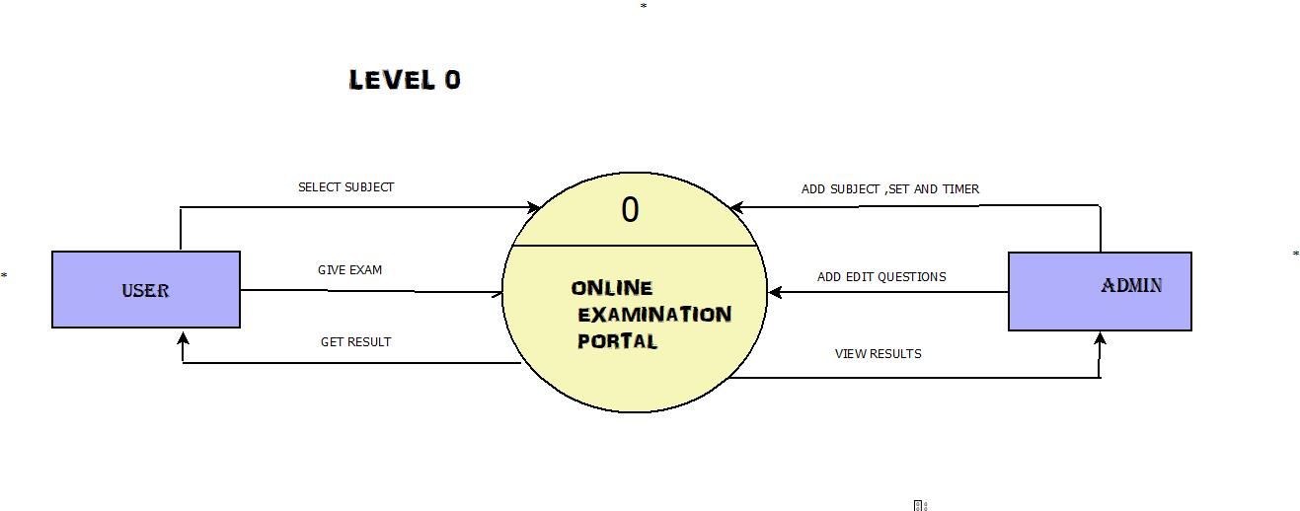

**LEVEL 1:**

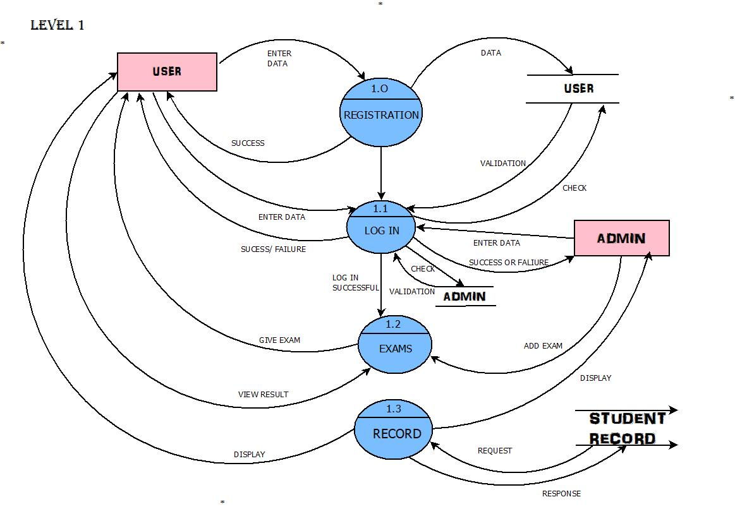

**LEVEL 2 (EXAM MODULE):**

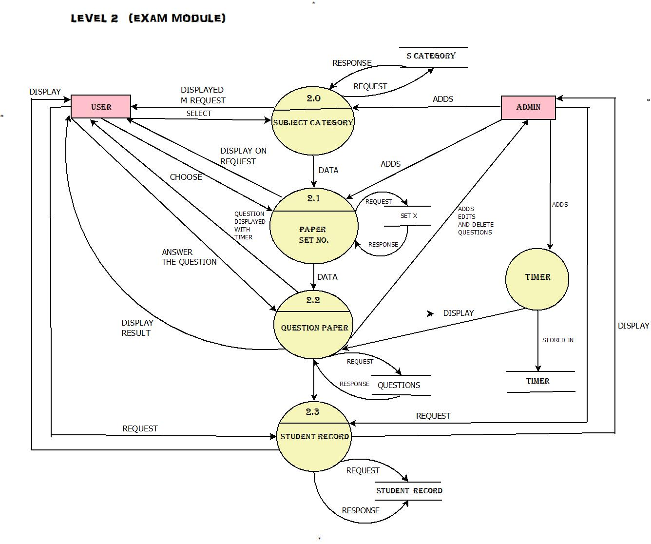

* **DATABASE DESIGN:**

**The database design or table design is the organization of data according to the database model. The database design involves classifying the data and identifying the interrelationships between them.**

**The database name is examportal.**

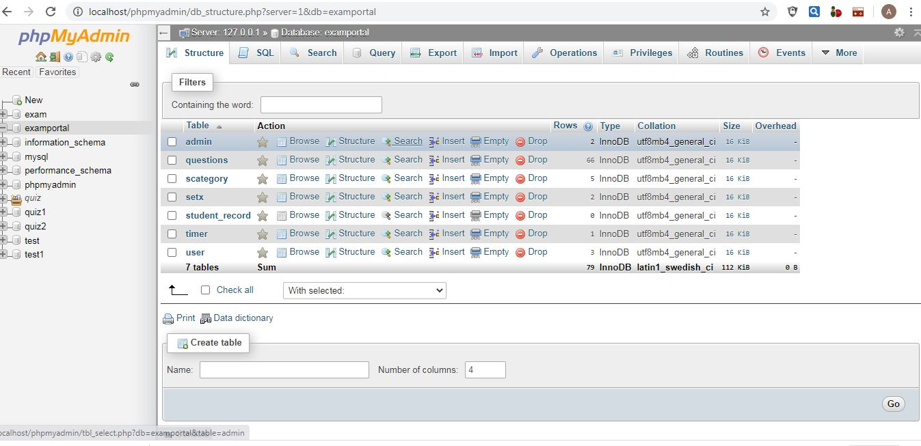

**The following tables are used:**

1. **admin - to store the admin information.**

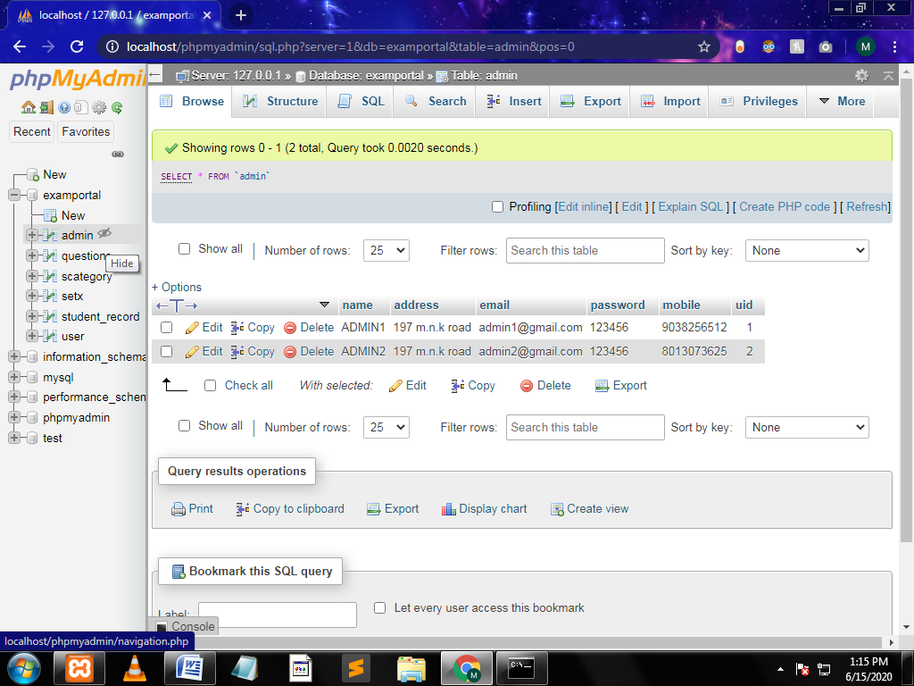

1. **scategory- to store Subject details**

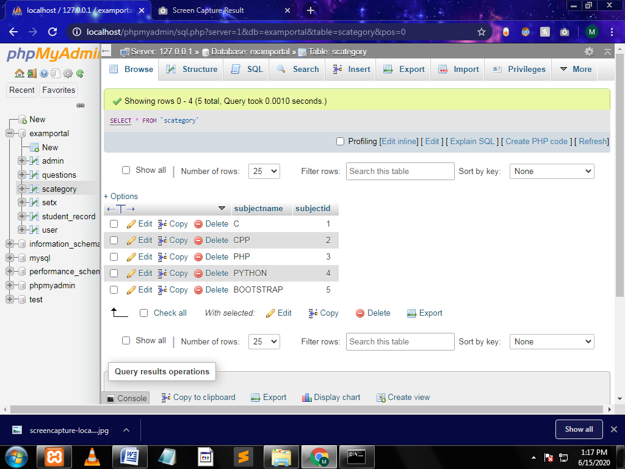

1. **setx- to store the question set number.**

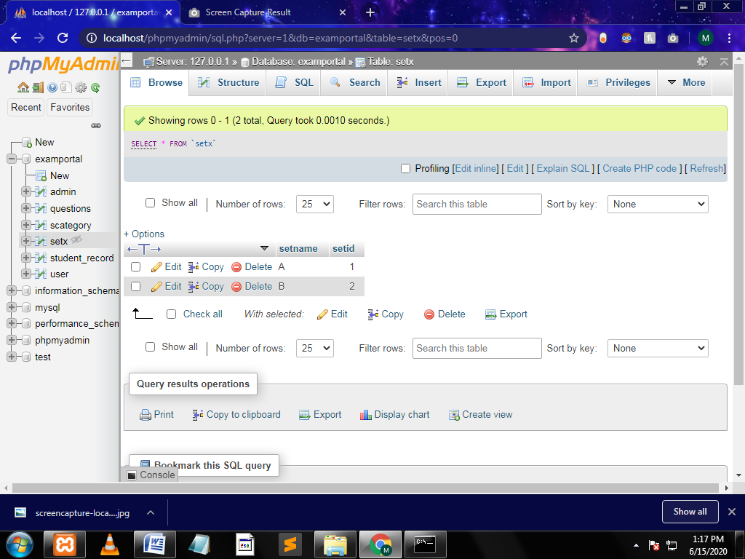

1. **question-to store the questions on each subject.**

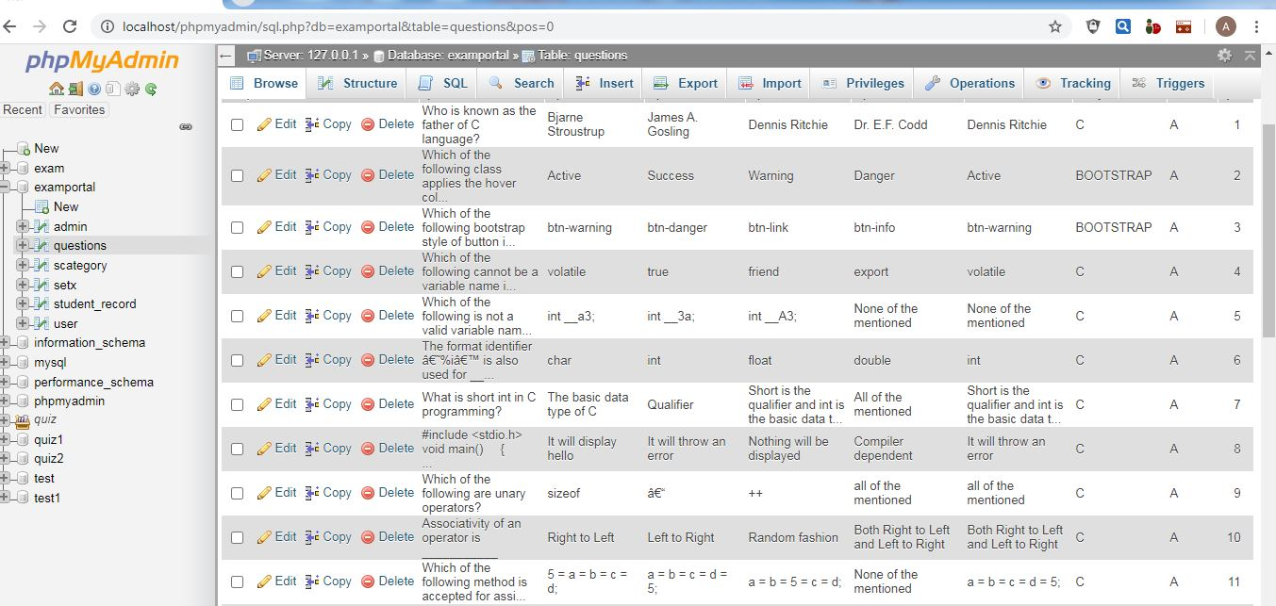

1. **student_record- to store the results of students.**

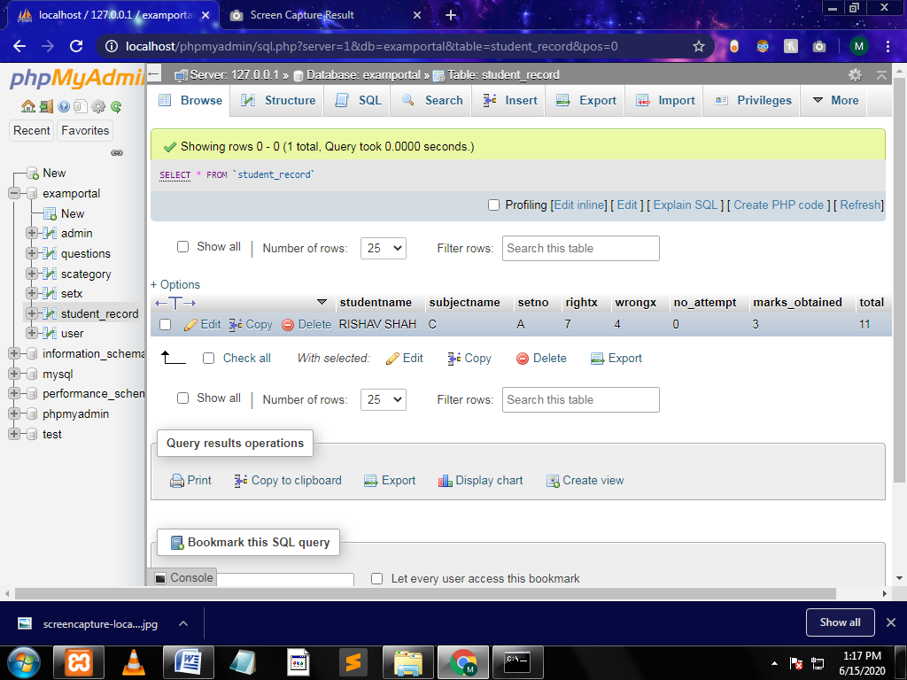

1. **user- to store the user details.**

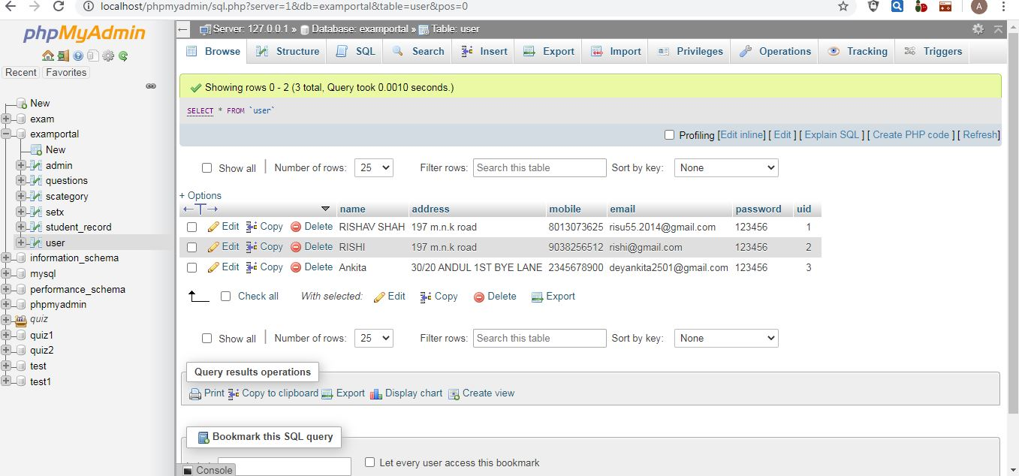

1. **timer- to store the timer details.**

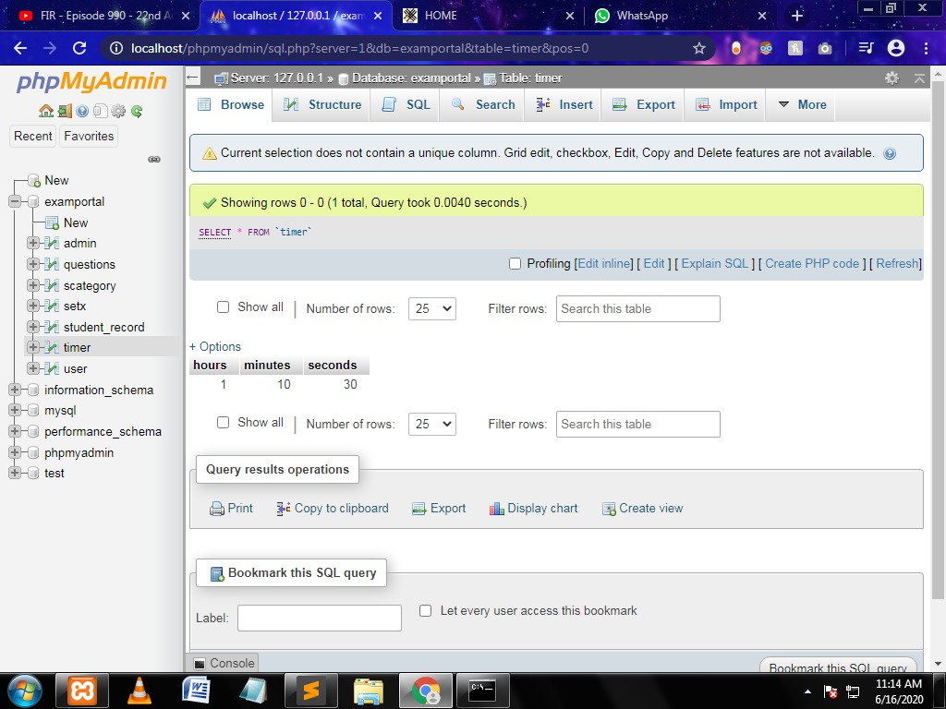

* **COCOMO**

Cocomo (Constructive Cost Model) is a regression model based on LOC, i.e. **number of Lines of Code**. It is a procedural cost estimate model for software projects and often used as a process of reliably predicting the various parameters associated with making a project such as size, effort, cost, time and quality. It was proposed by Barry Boehm in 1970 and is based on the study of 63 projects, which make it one of the best-documented models.

**Basic model equation:**

1. **Effort=a(KLOC) b**
2. **Tdev.= c(effort) d**

|  |  |  |  |  |
| --- | --- | --- | --- | --- |
| **Mode** | **A** | **b** | **C** | **d** |
| **Organic** | **2.4** | **1.05** | **2.5** | **0.38** |
| **Semi-detached** | **3.0** | **1.12** | **2.5** | **0.35** |
| **Embedded** | **3.6** | **1.20** | **2.5** | **0.32** |

**Considering the project to be of Organic Type:**

**KLOC=1.1**

**Effort=2.4(1.1)1.05 =2.65**

**Tdev= 2.5(2.65)0.38 =3.62 months**

**=4months (approx)**

* **SOURCE CODES**
* **Homepage(index1.php)**

<?php

session_start();

$db=mysqli_connect("localhost","root","","examportal") or die(mysqli_error($db));

?>

<!DOCTYPE HTML>

<html>

<head>

<meta charset="UTF-8">

<title> HOME </title>

<link rel = "icon" img href = "<?php echo base_url('img/newlogo.jpg') ?>"type = "image/x-icon">

<meta name="viewport" content="width=device-width, initial-scale=1">

<!-- Latest compiled and minified CSS -->

<link rel="stylesheet" href="https://maxcdn.bootstrapcdn.com/bootstrap/4.4.1/css/bootstrap.min.css">

<!-- jQuery library -->

<script src="https://ajax.googleapis.com/ajax/libs/jquery/3.5.1/jquery.min.js"></script>

<!-- Popper JS -->

<script src="https://cdnjs.cloudflare.com/ajax/libs/popper.js/1.16.0/umd/popper.min.js"></script>

<!-- Latest compiled JavaScript -->

<script src="https://maxcdn.bootstrapcdn.com/bootstrap/4.4.1/js/bootstrap.min.js"></script>

<link rel="stylesheet" type="text/css" href="indexstyle.css">

</head>

<body>

<div class="container-fluid">

<nav class="navbar navbar-expand-lg bg-dark navbar-dark">

<div class="container">

<a class="navbar-brand" href="#">

<img src="<?php echo base_url('img/newlogo.jpg') ?>" alt="Logo" style="width:200px; height:100px" >

</a>

<button class="navbar-toggler" type="button" data-toggle="collapse" data-target="#collapsenavbar">

<span class="navbar-toggler-icon"></span>

</button>

<div class="collapse navbar-collapse text-center" id="collapsenavbar">

<ul class="navbar-nav ml-auto">

<li class="nav-item">

<a href="" class="nav-link"> HOME</a>

</li>

<li class="nav-item dropdown">

<a class="nav-link dropdown-toggle" href="#" id="navbardrop" data-toggle="dropdown">

SUBJECTS

</a>

<div class="dropdown-menu">

<?php

$q="SELECT * FROM scategory";

$result=mysqli_query($db,$q);

while ($row= mysqli_fetch_array($result))

{

$cat=$row;

?>

<a class="dropdown-item" href=""><?php echo $cat['subjectname'] ?></a>

<?php } ?>

</div>

</li>

<li class="nav-item">

<a href="index.php/HOME/resultt" class="nav-link"> RESULT</a>

</li>

<li class="nav-item">

<a href="index.php/HOME/aboutus" class="nav-link">ABOUT US </a>

</li>

<li class="nav-item">

<a href="index.php/HOME/contactus" class="nav-link"> CONTACT US</a>

</li>

<li class="nav-item">

<?php

if(isset($_SESSION['email']))

{

//echo $_SESSION['name'];

?>

<li class="nav-item dropdown">

<a class="nav-link dropdown-toggle" href="" id="navbardrop" data-toggle="dropdown">

<?php echo $_SESSION['name']; ?>

</a>

<div class="dropdown-menu">

<a href="index.php/HOME/logout1" class="btn btn-primary"> LOGOUT</a>

<?php

}

else

{

?>

<a href="index.php/HOME/loginuser" class="nav-link"> LOGIN</a>

<?php

}

?>

</li>

</ul>

</div>

</div>

</nav>

</div>

<nav class="navbar navbar-expand-sm bg-danger ">

</nav>

<div id="demo" class="carousel slide" data-ride="carousel">

<!-- Indicators -->

<ul class="carousel-indicators">

<li data-target="#demo" data-slide-to="0" class="active"></li>

<li data-target="#demo" data-slide-to="1"></li>

<li data-target="#demo" data-slide-to="2"></li>

</ul>

<br>

<!-- The slideshow -->

<div class="carousel-inner">

<div class="carousel-item active">

<img img src="<?php echo base_url('img/carousel5.jpg') ?>" alt="1" width="1350" height="300">

</div>

<div class="carousel-item">

<img img src="<?php echo base_url('img/carousel12.jpg') ?>" alt="2" width="1350" height="300">

</div>

<div class="carousel-item">

<img img src="<?php echo base_url('img/carousel11.jpg') ?>" alt="3" width="1350" height="300">

</div>

</div>

<!-- Left and right controls -->

<a class="carousel-control-prev" href="#demo" data-slide="prev">

<span class="carousel-control-prev-icon"></span>

</a>

<a class="carousel-control-next" href="#demo" data-slide="next">

<span class="carousel-control-next-icon"></span>

</a>

</div>

</div>

</div>

<div class="container-fluid">

<br>

<h3 style="text-align:center;"><u>

<?php

if (isset($_SESSION['emailuser'])) {

?>

<a href="index.php/home/userportal">

<b>PLEASE SELECT THE SUBJECT </b></a></u></h3><br>

<?php

}

elseif (isset($_SESSION['emailadmin'])) {

?>

<a href="index.php/home/adminportal">

<b>ADMIN PORTAL</b></a></u></h3><br>

<?php

}

else{

?>

<a href="">

<b>PLEASE SELECT THE SUBJECT <br><h4>(PLEASE LOGIN FIRST)</h4></b></a></u></h3><br>

<?php

}

?>

<br>

</div>

</div>

</body>

</html>

* **Registration page(registeruser.php)**

<?php

session_start();

//connect to database

$db=mysqli_connect("localhost","root","","examportal") or die(mysqli_error($db));

//require 'connection.php';

if (isset($_POST['register_btn']))

{

$name=$_POST['name'];

$address=$_POST['address'];

$mobile=$_POST['mobile'];

$email=$_POST['email'];

$password=$_POST['password'];

$cpassword=$_POST['cpassword'];

$lq="SELECT email FROM user WHERE email='$email' ";

$result=mysqli_query($db,$lq);

$count=mysqli_num_rows($result);

if ($count>0)

{

echo '<script>alert("EMAIL ALREADY EXISTS. ENTER NEW EMAIL ID")</script>';

// echo "not same";

// $_SESSION['message']="TWO PASSWORDS DO NOT MATCH. ENTER AGAIN";

//echo "$_SESSION['message']";

// echo "<div>".$_SESSION['message']."</div>";

// echo "one row inserted";

//create user

// $password=md5($password);

// return redirect()->route('loginuser');

}

else

{

$q="INSERT INTO user (address,mobile,email,password,name) VALUES('$address','$mobile','$email','$password','$name')";

mysqli_query($db,$q);

echo '<script>alert("YOU ARE NOW REGISTERED AS A USER")

window.location.href= "loginuser";</script>';

//$_SESSION['message']= "YOU ARE NOW REGISTERED";

// $_SESSION['name']=$_POST['name'];

// echo "<div>".$_SESSION['username']."</div>";

//header("location: index"); //back to home page

// echo "<div>".$_SESSION['message']."</div>";

/* $routes->setDefaultMethod('index');

echo ' <script>

windows.location="loginuser"

</script>';*/

//redirect('loginuser');

// $this->load->view('loginuser');

}

}

?>

</h3>

</body>

</html>

<!DOCTYPE HTML>

<html>

<head>

<title>USER REGISTRATION</title>

<link rel = "icon" href = "brandlogo.png" type = "image/x-icon">

<meta name="viewport" content="width=device-width, initial-scale=1">

<meta charset="utf-8">

<script src="https://code.jquery.com/jquery-1.12.4.js"></script>

<script src="https://cdnjs.cloudflare.com/ajax/libs/1000hz-bootstrap-validator/0.11.5/validator.min.js"></script>

<!-- Latest compiled and minified CSS -->

<link rel="stylesheet" href="https://maxcdn.bootstrapcdn.com/bootstrap/4.4.1/css/bootstrap.min.css">

<link rel = "icon" img href = "<?php echo base_url('img/newlogo.jpg') ?>"type = "image/x-icon">

<!-- jQuery library -->

<script src="https://ajax.googleapis.com/ajax/libs/jquery/3.5.1/jquery.min.js"></script>

<!-- Popper JS -->

<script src="https://cdnjs.cloudflare.com/ajax/libs/popper.js/1.16.0/umd/popper.min.js"></script>

<!-- Latest compiled JavaScript -->

<script src="https://maxcdn.bootstrapcdn.com/bootstrap/4.4.1/js/bootstrap.min.js"></script>

<meta name="viewport" content="width=device-width, initial-scale=1">

<link rel="stylesheet" href="https://pro.fontawesome.com/releases/v5.10.0/css/all.css" integrity="sha384-AYmEC3Yw5cVb3ZcuHtOA93w35dYTsvhLPVnYs9eStHfGJvOvKxVfELGroGkvsg+p" crossorigin="anonymous"/>

<style>

body{

background-image: url('mylogin.jpg');

background-size: cover;

background-repeat: no-repeat;

height" 100%;

font-family: "Numans","Serif";

}

label{

color: hotpink;

display:block;

padding: 10px;

}

.container{

height: 100%;

align-content: center;

}

.card{

height : 970px;

margin-top: 60px;

margin-bottom: auto;

width: 400px;

background-color: rgba(0,0,0,0.5);

}

.social_icon span{

font-size: 40px;

margin-left: 10px;

color: #FFC312;

}

.social_icon span:hover{

color: white;

cursor: pointer;

}

.card-header h3{

color: lightcoral;

}

.remember{

color: white;

}

.remember input{

width: 20px;

height: 20px

margin-left: 15px;

margin-right: 5px;

}

a{

color: lightcoral;

}

i{

color: lightcoral;

}

i:hover{

color:white;

background-color: black;

}

.login_btn{

color: black;

background-color: lightcoral;

width: 100px;

}

.login_btn:hover{

color: black;

background-color: white;

}

.links{

color: white;

}

.links a{

margin-left: 10px;

}

</style>

<link rel="stylesheet" type="text/css" href="loginstyle.css">

<script src="major/4.4.1/js/bootstrap.min.js"></script>

<div class="container-fluid">

<nav class="navbar navbar-expand-lg bg-dark navbar-dark">

<div class="container">

<a class="navbar-brand" href="#">

<img src="<?php echo base_url('img/newlogo.jpg') ?>" alt="Logo" style="width:200px; height:100px" >

</a>

<button class="navbar-toggler" type="button" data-toggle="collapse" data-target="#collapsenavbar">

<span class="navbar-toggler-icon"></span>

</button>

<div class="collapse navbar-collapse text-center" id="collapsenavbar">

<ul class="navbar-nav ml-auto">

<li class="nav-item">

<a href="http://localhost/major/public/" class="nav-link"> HOME</a>

</li>

<li class="nav-item dropdown">

<a class="nav-link dropdown-toggle" href="#" id="navbardrop" data-toggle="dropdown">

SUBJECTS

</a>

<div class="dropdown-menu">

<?php

$q="SELECT * FROM scategory";

$result=mysqli_query($db,$q);

while ($row= mysqli_fetch_array($result))

{

$cat=$row;

?>

<a class="dropdown-item" href=""><?php echo $cat['subjectname'] ?></a>

<?php } ?>

</div>

</li>

<li class="nav-item">

<a href="resultt" class="nav-link"> RESULT</a>

</li>

<li class="nav-item">

<a href="aboutus" class="nav-link">ABOUT US </a>

</li>

<li class="nav-item">

<a href="contactus" class="nav-link"> CONTACT US</a>

</li>

</ul>

</div>

</div>

</nav>

</div>

<nav class="navbar navbar-expand-sm bg-danger ">

</nav>

</head>

<body>

<div class="container">

<div class="d-flex justify-content-center h-100">

<div class="card">

<form data-toggle="validator" role="form" method="POST" action="registeruser">

<div class="card-header">

<h3>USER REGISTER HERE </h3>

</div>

<div class="card-body">

<div class= "form-group">

<label for="inputName" class="control-label"> NAME:</label>

<input type="text" class="form-control" id="inputName" placeholder="NAME " name="name" required>

</div>

<div class="form-group">

<label for="inputAdd" class="control-label"> ADDRESS: </label>

<input type="text" class="form-control" id="inputAdd" placeholder="ADDRESS " name="address" required>

</div>

<div class="form-group has-feedback">

<label for="inputMobile" class="control-label"> MOBILE:</label>

<input type="text" pattern="^[_0-9]{1,}$" data-minlength="10" maxlength="10" class="form-control" id="inputMobile" placeholder="MOBILE " name="mobile" required>

<span class="glyphicon form-control-feedback" aria-hidden="true" ></span>

<div class="help-block with-errors"><label> ENTER ONLY 10 DIGIT NUMBERS</label></div>

</div>

<div class="form-group">

<label for="inputEmail" class="control-label"> EMAIL: </label>

<input type="email" class="form-control" id="inputEmail" placeholder="EMAIL " data-error="ENTER VALID EMAIL ADDRESS" name="email" required>

<div class="help-block with-errors"></div>

</div>

<div class="form-group">

<label for="inputPassword" class="control-label"> PASSWORD: </label>

<input type="password" data-minlength="6" class="form-control" id="inputPassword" placeholder="PASSWORD" data-error="INVALID PASSWORD" name="password" required>

<div class="help-block with-errors"></div>

</div>

<div class="form-group">

<label for="inputPassword" class="control-label"> CONFIRM PASSWORD: </label>

<input type="password" class="form-control" id="inputPasswordconfirm" data-match="#inputPassword" data-match-error="PASSWORD DID NOT MATCH" placeholder="CONFIRM PASSWORD" name="cpassword" required>

<div class="help-block with-errors"></div>

</div>

<div class="form-group">

<div class="checkbox">

<label>

<input type="checkbox" id="terms" data-error="please agree to the terms and conditions first" required>

I AGREE TO THE TERMS AND CONDITIONS</label>

<div class="help-block with-errors"></div>

</div>

</div>

<div class="form-group">

<button type="submit" name="register_btn" class="btn float reg_btn">REGISTER </button>

</div>

<div class="card-footer">

<p>Already a member??</p><a href="loginuser">LOGIN</a>

</div>

</div>

</form>

</div>

</div>

</div>

</body>

</html>

* **Login page(loginuser.php)**

<?php

session_start();

//connect to database

$db=mysqli_connect("localhost","root","","examportal") or die(mysqli_error($db));

if (isset($_POST['login_btn']))

{

// $username=$_POST['username'];

$email=$_POST['email'];

$password=$_POST['password'];

// $password2=$_POST['password2'];

// $password=md5($password);

$q="SELECT * FROM user WHERE email='$email'";

$result=mysqli_query($db,$q);

while ($row= mysqli_fetch_assoc($result)) {

$pswdb=$row['password'];

$namedb=$row['name'];

}

if ($pswdb==$password) {

// echo "abc";

$_SESSION['email']=$email;

$_SESSION['emailuser']=$email;

$_SESSION['name']=$namedb;

// PHP program to pop an alert

// message box on the screen

// Display the alert box

echo '<script>alert("YOU ARE NOW LOGGED IN AS A USER")</script>';

?>

<script type="text/javascript">

window.location.href= "http://localhost/major/public/ ";

</script>

<?php

//return redirect()->to('http://localhost/major/public/index.php/HOME/adminportal');

// return redirect('adminportal','refresh');

// $_SESSION['message']= "YOU ARE NOW LOGGED IN AS A USER";

// $_SESSION['username']=$_POST['username'];

// header("location: index"); //back to home page

// echo "<div>".$_SESSION['message']."</div>";

// mysql_close($db);

}

else

{

echo '<script>alert("INCORRECT USERNAME/PASSWORD")</script>';

// header("location: home2.php");

// $_SESSION['message']="INCORRECT USERNAME/PASSWORD";

$a=$_SESSION['message'];

echo "<div>".$_SESSION['message']."</div>";

}

}

?>

<!DOCTYPE HTML>

<html>

<head>

<title> USER LOGIN </title>

<link rel = "icon" href = "brandlogo.png" type = "image/x-icon">

<meta name="viewport" content="width=device-width, initial-scale=1">

<meta charset="utf-8">

<!-- Latest compiled and minified CSS -->

<link rel="stylesheet" href="https://maxcdn.bootstrapcdn.com/bootstrap/4.4.1/css/bootstrap.min.css">

<!-- jQuery library -->

<script src="https://ajax.googleapis.com/ajax/libs/jquery/3.5.1/jquery.min.js"></script>

<!-- Popper JS -->

<script src="https://cdnjs.cloudflare.com/ajax/libs/popper.js/1.16.0/umd/popper.min.js"></script>

<!-- Latest compiled JavaScript -->

<script src="https://maxcdn.bootstrapcdn.com/bootstrap/4.4.1/js/bootstrap.min.js"></script>

<meta name="viewport" content="width=device-width, initial-scale=1">

<link rel="stylesheet" href="https://pro.fontawesome.com/releases/v5.10.0/css/all.css" integrity="sha384-AYmEC3Yw5cVb3ZcuHtOA93w35dYTsvhLPVnYs9eStHfGJvOvKxVfELGroGkvsg+p" crossorigin="anonymous"/>

<link rel = "icon" img href = "<?php echo base_url('img/newlogo.jpg') ?>"type = "image/x-icon">

<style>

body{

background-image: url('mylogin.jpg');

background-size: cover;

background-repeat: no-repeat;

height" 100%;

font-family: "Numans","Serif";

}

label{

color: hotpink;

display:block;

padding: 10px;

}

.container{

height: 100%;

align-content: center;

}

.card{

height : 450px;

margin-top: 60px;

margin-bottom: auto;

width: 400px;

background-color: rgba(0,0,0,0.5);

}

.social_icon span{

font-size: 40px;

margin-left: 10px;

color: #FFC312;

}

.social_icon span:hover{

color: white;

cursor: pointer;

}

.card-header h3{

color: lightcoral;

}

.remember{

color: white;

}

.remember input{

width: 20px;

height: 20px

margin-left: 15px;

margin-right: 5px;

}

a{

color: lightcoral;

}

i{

color: lightcoral;

}

i:hover{

color:white;

background-color: black;

}

.login_btn{

color: black;

background-color: lightcoral;

width: 100px;

}

.login_btn:hover{

color: black;

background-color: white;

}

.links{

color: white;

}

.links a{

margin-left: 10px;

}

</style>

<link rel="stylesheet" type="text/css" href="loginstyle.css">

<script src="major/4.4.1/js/bootstrap.min.js"></script>

<div class="container-fluid">

<nav class="navbar navbar-expand-lg bg-dark navbar-dark">

<div class="container">

<a class="navbar-brand" href="#">

<img src="<?php echo base_url('img/newlogo.jpg') ?>" alt="Logo" style="width:200px; height:100px" >

</a>

<button class="navbar-toggler" type="button" data-toggle="collapse" data-target="#collapsenavbar">

<span class="navbar-toggler-icon"></span>

</button>

<div class="collapse navbar-collapse text-center" id="collapsenavbar">

<ul class="navbar-nav ml-auto">

<li class="nav-item">

<a href="http://localhost/major/public/" class="nav-link"> HOME</a>

</li>

<li class="nav-item dropdown">

<a class="nav-link dropdown-toggle" href="#" id="navbardrop" data-toggle="dropdown">

SUBJECTS

</a>

<div class="dropdown-menu">

<?php

$q="SELECT * FROM scategory";

$result=mysqli_query($db,$q);

while ($row= mysqli_fetch_array($result))

{

$cat=$row;

?>

<a class="dropdown-item" href=""><?php echo $cat['subjectname'] ?></a>

<?php } ?>

</div>

</li>

<li class="nav-item">

<a href="resultt" class="nav-link"> RESULT</a>

</li>

<li class="nav-item">

<a href="aboutus" class="nav-link">ABOUT US </a>

</li>

<li class="nav-item">

<a href="contactus" class="nav-link"> CONTACT US</a>

</li>

</ul>

</div>

</div>

</nav>

</div>

</head>

<body>

<nav class="navbar navbar-expand-sm bg-danger ">

</nav>

<?php

?>

<div class="container">

<div class="d-flex justify-content-center h-100">

<div class="card">

<form class="form-horizontal" role="form" method="POST" action="loginuser">

<div class="card-header">

<h3>USER LOGIN HERE </h3>

<div class="d-flex justify-content-end social_icon">

<span> <a href="http://www.facebook.com"><i class="fab fa-facebook-square"></i></a>

</span>

<span> <a href="http://www.gmail.com"><i class="fab fa-google-plus-square"></i></a>

</span>

<span> <a href="http://www.twitter.com"><i class="fab fa-twitter-square"></i></a>

</span>

</div>

</div>

<div class="card-body">

<div class="input-group form-group">

<div class="input-group-prepend">

<span class="input-group-text"><i class="fa fa-user" aria-hidden="true"></i>

</span>

</div>

<input type="text" class="form-control" placeholder="EMAIL" name="email" required autofocus>

</div>

<div class="input-group form-group">

<div class="input-group-prepend">

<span class="input-group-text"><i class="fa fa-key" aria-hidden="true"></i>

</span>

</div>

<input type="password" class="form-control" placeholder="PASSWORD" name="password" required autofocus>

</div>

<div class="row align-items-center remember">

<input type="checkbox"> REMEMBER ME?

</div>

<div class="form-group">

<input type="submit" name="login_btn" value="LOGIN" class="btn float-right login_btn">

</div>

</form>

<br>

<div class="card-footer">

<div class="d-flex justify-content-center links">Don't have an account?<a href="registeruser">Sign Up</a>

</div>

<br>

<div class="d-flex justify-content-center links">ARE U AN ADMIN?<a href="loginadmin">LOGIN</a>

</div>

<br>

<div class="d-flex justify-content-center "> <a href="forget.html">FORGOT PASSWORD?</a>

</div>

</div>

</div>

</form>

</div>

</div>

</div>

</body>

</html>

* **Select exam(userportal.php)**

<?php

session_start();

if (isset($_SESSION['emailuser'])) {

$db=mysqli_connect("localhost","root","","examportal") or die(mysqli_error($db));

?>

<!DOCTYPE HTML>

<html>

<head>

<meta charset="UTF-8">

<title> USER PORTAL </title>

<link rel = "icon" img href = "<?php echo base_url('img/newlogo.jpg') ?>"type = "image/x-icon">

<meta name="viewport" content="width=device-width, initial-scale=1">

<!-- Latest compiled and minified CSS -->

<link rel="stylesheet" href="https://maxcdn.bootstrapcdn.com/bootstrap/4.4.1/css/bootstrap.min.css">

<!-- jQuery library -->

<script src="https://ajax.googleapis.com/ajax/libs/jquery/3.5.1/jquery.min.js"></script>

<!-- Popper JS -->

<script src="https://cdnjs.cloudflare.com/ajax/libs/popper.js/1.16.0/umd/popper.min.js"></script>

<!-- Latest compiled JavaScript -->

<script src="https://maxcdn.bootstrapcdn.com/bootstrap/4.4.1/js/bootstrap.min.js"></script>

<link rel="stylesheet" href="https://pro.fontawesome.com/releases/v5.10.0/css/all.css" integrity="sha384-AYmEC3Yw5cVb3ZcuHtOA93w35dYTsvhLPVnYs9eStHfGJvOvKxVfELGroGkvsg+p" crossorigin="anonymous"/>

<style>

body{

background-image: url('mylogin.jpg');

background-size: cover;

background-repeat: no-repeat;

height" 100%;

font-family: "Numans","Serif";

}

label{

color: hotpink;

display:block;

padding: 10px;

}

.container{

height: 100%;

align-content: center;

}

.card{

height :100%;

margin-top: 60px;

margin-bottom: auto;

width: 400px;

background-color: rgba(0,0,0,0.5);

}

.social_icon span{

font-size: 40px;

margin-left: 10px;

color: #FFC312;

}

.social_icon span:hover{

color: white;

cursor: pointer;

}

.card-header h3{

color: lightcoral;

}

.remember{

color: white;

}

.remember input{

width: 20px;

height: 20px

margin-left: 15px;

margin-right: 5px;

}

a{

color: lightcoral;

}

i{

color: lightcoral;

}

i:hover{

color:white;

background-color: black;

}

.login_btn{

color: black;

background-color: lightcoral;

width: 100px;

}

.login_btn:hover{

color: black;

background-color: white;

}

.links{

color: white;

}

.links a{

margin-left: 10px;

}

</style>

<div class="container-fluid">

<nav class="navbar navbar-expand-lg bg-dark navbar-dark">

<div class="container">

<a class="navbar-brand" href="#">

<img src="<?php echo base_url('img/newlogo.jpg') ?>" alt="Logo" style="width:200px; height:100px" >

</a>

<button class="navbar-toggler" type="button" data-toggle="collapse" data-target="#collapsenavbar">

<span class="navbar-toggler-icon"></span>

</button>

<div class="collapse navbar-collapse text-center" id="collapsenavbar">

<ul class="navbar-nav ml-auto">

<li class="nav-item">

<a href="http://localhost/major/public/" class="nav-link"> HOME</a>

</li>

<li class="nav-item dropdown">

<a class="nav-link dropdown-toggle" href="#" id="navbardrop" data-toggle="dropdown">

SUBJECTS

</a>

<div class="dropdown-menu">

<?php

$q="SELECT * FROM scategory";

$result=mysqli_query($db,$q);

while ($row= mysqli_fetch_array($result))

{

$cat=$row;

?>

<a class="dropdown-item" href=""><?php echo $cat['subjectname'] ?></a>

<?php } ?>

</div>

</li>

<li class="nav-item">

<a href="resultt" class="nav-link"> RESULT</a>

</li>

<li class="nav-item">

<a href="aboutus" class="nav-link">ABOUT US </a>

</li>

<li class="nav-item">

<a href="contactus" class="nav-link"> CONTACT US</a>

</li>

<li class="nav-item">

<?php

if(isset($_SESSION['email']))

{

//echo $_SESSION['name'];

?>

<li class="nav-item dropdown">

<a class="nav-link dropdown-toggle" href="" id="navbardrop" data-toggle="dropdown">

<?php echo $_SESSION['name']; ?>

</a>

<div class="dropdown-menu">

<a href="index.php/HOME/logout1" class="btn btn-primary"> LOGOUT</a>

<?php

}

else

{

?>

<a href="loginuser" class="nav-link"> LOGIN</a>

<?php

}

?>

</li>

</ul>

</div>

</div>

</nav>

</div>

</head>

<body>

<nav class="navbar navbar-expand-sm bg-danger ">

</nav>

</div>

<div class="container-fluid">

<br>

<br>

<div class="container">

<div class="d-flex justify-content-center h-100">

<div class="card">

<div class="card-header">

<h3>CHOOSE SUBJECT </h3>

</div>

<div class="card-body">

<form class="form-horizontal" role="form" method="POST" action="userexamportal">

<center> <select name="subj">

<option > choose subject </option>

<?php

$q="SELECT * FROM scategory";

$result=mysqli_query($db,$q);

while ($row= mysqli_fetch_array($result))

{

$cat=$row;

?>

<option value="<?php echo $cat['subjectname'] ?>"><?php echo $cat['subjectname'] ?></option>

<?php } ?>

</select>

<br><br>

<select name="setno">

<option > choose set </option>

<?php

$q="SELECT * FROM setx";

$result=mysqli_query($db,$q);

while ($row= mysqli_fetch_array($result))

{

$cat=$row;

?>

<option value="<?php echo $cat['setname'] ?>"><?php echo $cat['setname'] ?></option>

<?php } ?>

</select>

<br><br>

<input type="submit" name="login_btn" value="BEGIN TEST" class="btn float-center login_btn">

</center>

</form>

<br>

</div>

<br>

</div>

</div>

</div>

</div>

</div>

</div>

</body>

</html>

<?php

}

else

{

echo '<script>alert("ONLY FOR STUDENTS")

window.location.href= "http://localhost/major/public/"

</script>';

;

}

?>

* **Questions(userexamportal.php)**

<?php

session_start();

if (isset($_SESSION['emailuser'])) {

//connect to database

$db=mysqli_connect("localhost","root","","examportal") or die(mysqli_error($db));

//require 'connection.php';

$_SESSION['subject'] =$_POST['subj'] ;

$subj=$_POST['subj'] ;

$setno=$_POST['setno'];

?>

<!DOCTYPE html>

<html>

<head>

<title>EXAM PORTAL</title>

<link rel="stylesheet" type="text/css" href="homestyle.css">

<link rel = "icon" img href = "<?php echo base_url('img/newlogo.jpg') ?>"type = "image/x-icon">

<meta name="viewport" content="width=device-width, initial-scale=1">

<meta charset="utf-8">

<!-- Latest compiled and minified CSS -->

<link rel="stylesheet" href="https://maxcdn.bootstrapcdn.com/bootstrap/4.4.1/css/bootstrap.min.css">

<!-- jQuery library -->

<script src="https://ajax.googleapis.com/ajax/libs/jquery/3.5.1/jquery.min.js"></script>

<!-- Popper JS -->

<script src="https://cdnjs.cloudflare.com/ajax/libs/popper.js/1.16.0/umd/popper.min.js"></script>

<!-- Latest compiled JavaScript -->

<script src="https://maxcdn.bootstrapcdn.com/bootstrap/4.4.1/js/bootstrap.min.js"></script>

<meta name="viewport" content="width=device-width, initial-scale=1">

<link rel="stylesheet" href="https://pro.fontawesome.com/releases/v5.10.0/css/all.css" integrity="sha384-AYmEC3Yw5cVb3ZcuHtOA93w35dYTsvhLPVnYs9eStHfGJvOvKxVfELGroGkvsg+p" crossorigin="anonymous"/>

<style type="text/css">

body{

background-image: url('mylogin.jpg');

background-size: cover;

background-repeat: no-repeat;

height" 100%;

font-family: "Numans","Serif";

}

.container{

height: 100%;

}

#subjects{

width: 100%;

}

.card{

height : 250px;

margin-top: 0px;

margin-bottom: 20px;

width: 300px;

background-color: rgba(0,0,0,0.5);

}

label{

color: white;

display:block;

padding: 10px;

}

.card-header h3{

color: lightcoral;

}

.reg_btn{

color: black;

background-color: lightcoral;

width: 100px;

}

.login_btn{

color: black;

background-color: red;

width: 100px;

}

.login_btn:hover{

color: black;

background-color: yellow;

}

.reg_btn:hover{

color: black;

background-color: white;

}

a{

color: lightcoral;

}

.container-fluid {

/* opacity: 0.5; */

color: lightcoral;

}

</style>

<div class="container-fluid">

<nav class="navbar navbar-expand-lg bg-dark navbar-dark">

<div class="container">

<a class="navbar-brand" href="#">

<img src="<?php echo base_url('img/newlogo.jpg') ?>" alt="Logo" style="width:200px; height:100px" >

</a>

<button class="navbar-toggler" type="button" data-toggle="collapse" data-target="#collapsenavbar">

<span class="navbar-toggler-icon"></span>

</button>

<div class="collapse navbar-collapse text-center" id="collapsenavbar">

<ul class="navbar-nav ml-auto">

<li class="nav-item">

<a href="http://localhost/major/public/" class="nav-link"> HOME</a>

</li>

<li class="nav-item dropdown">

<a class="nav-link dropdown-toggle" href="#" id="navbardrop" data-toggle="dropdown">

SUBJECTS

</a>

<div class="dropdown-menu">

<?php

$q="SELECT * FROM scategory";

$result=mysqli_query($db,$q);

while ($row= mysqli_fetch_array($result))

{

$cat=$row;

?>

<a class="dropdown-item" href=""><?php echo $cat['subjectname'] ?></a>

<?php } ?>

</div>

</li>

<li class="nav-item">

<a href="resultt" class="nav-link"> RESULT</a>

</li>

<li class="nav-item">

<a href="aboutus" class="nav-link">ABOUT US </a>

</li>

<li class="nav-item">

<a href="contactus" class="nav-link"> CONTACT US</a>

</li>

<li class="nav-item">

<?php

if(isset($_SESSION['email']))

{

//echo $_SESSION['name'];

?>

<li class="nav-item dropdown">

<a class="nav-link dropdown-toggle" href="" id="navbardrop" data-toggle="dropdown">

<?php echo $_SESSION['name']; ?>

</a>

<div class="dropdown-menu">

<a href="logout1" class="btn btn-primary"> LOGOUT</a>

<?php

}

else

{

?>

<a href="loginuser" class="nav-link"> LOGIN</a>

<?php

}

?>

</li>

</ul>

</div>

</div>

</nav>

</div>

<script>

var hoursleft = 1;

var minutesleft = 10; //give minutes you wish

var secondsleft = 30; // give seconds you wish

var finishedtext = "Countdown finished!";

var end1;

if(localStorage.getItem("end1"))

{

end1 = new Date(localStorage.getItem("end1"));

} else {

end1 = new Date();

end1.setHours(end1.getHours()+hoursleft);

end1.setMinutes(end1.getMinutes()+minutesleft);

end1.setSeconds(end1.getSeconds()+secondsleft);

}

var counter = function () {

var now = new Date();

var diff = end1 - now;

diff = new Date(diff);

var milliseconds = parseInt((diff%1000)/100)

var sec = parseInt((diff/1000)%60)

var mins = parseInt((diff/(1000*60))%60)

var hours = parseInt((diff/(1000*60*60))%24);

if (hours < 10) {

hours = "0" + hours;

}

if (mins < 10) {

mins = "0" + mins;

}

if (sec < 10) {

sec = "0" + sec;

}

if(now >= end1) {

clearTimeout(interval);

// localStorage.setItem("end", null);

localStorage.removeItem("end1");

localStorage.clear();

document.getElementById('divCounter').innerHTML = finishedtext;

alert("TIME UP!")

document.getElementById("form1").submit();

} else {

var value = hours + ":" +mins + ":" + sec;

localStorage.setItem("end1", end1);

document.getElementById('divCounter').innerHTML = value;

}

}

var interval = setInterval(counter, 1000);

</script>

</head>

<body >

<nav class="navbar navbar-expand-sm bg-danger ">

</nav>

<br>

<br>

</script>

<div style=" position: fixed; text-align: center; background-color: red;z-index: 1000">

<div id="divCounter"></div>

</div>

<br>

<div class="container">

<div class="d-flex justify-content-center h-100">

<div class="col-sm-8" style="background-color:lavender;">

<div class="card-header">

<h3> <?php echo $_SESSION['subject'] ; ?> </h3>

</div>

<div class="card-body">

<form class="form-horizontal" id="form1" role="form" method="POST" action="result">

<?php

$i=1;

$q="SELECT * FROM questions WHERE subjectname='$subj' AND setno='$setno'";

$result=mysqli_query($db,$q);

while ($row= mysqli_fetch_array($result))

{$cat=$row;

?>

<div style="background-color: pink;">

<?php

echo "$i"; $i++; ?> . <?php

echo $cat['question']; ?> <br>

<?php if(isset( $cat['opt1'])){?>

<input type="radio" id="opt1" name="<?php

echo $cat['qid']; ?>" value=" <?php echo $cat['opt1']; ?>"> <?php echo $cat['opt1']; } ?> <br><br>

<?php if(isset( $cat['opt2'])){?>

<input type="radio" id="opt2" name="<?php

echo $cat['qid']; ?>" value=" <?php echo $cat['opt2']; ?>"> <?php echo $cat['opt2']; } ?> <br><br>

<?php if(isset( $cat['opt3'])){?>

<input type="radio" id="opt3" name="<?php

echo $cat['qid']; ?>" value=" <?php echo $cat['opt3']; ?>"> <?php echo $cat['opt3']; } ?> <br><br>

<?php if(isset( $cat['opt4'])){?>

<input type="radio" id="opt4" name="<?php

echo $cat['qid']; ?>" value=" <?php echo $cat['opt4']; ?>"> <?php echo $cat['opt4'];} ?> <br><br>

<input type="radio" checked="checked" style="display:none" value="no_attempt" name="<?php echo $cat['qid']; ?>" />

</div>

</br>

<?php

}

?>

<input type="submit" onclick="d1();" name="abc" class="btn float-right login_btn">

<script type="text/javascript">

function d1() {

clearTimeout(interval);

// localStorage.setItem("end", null);

localStorage.removeItem("end1");

localStorage.clear();

//document.getElementById('divCounter').innerHTML = finishedtext;

document.getElementById("form1").submit();

}

</script>

</form>

</div>

</div>

</div>

</body>

</html>

<?php

}

else

{

echo '<script>alert("ONLY FOR STUDENTS")

window.location.href= "http://localhost/major/public/"

</script>';

;

}

?>

* **Result(result.php)**

<?php

session_start();

if (isset($_SESSION['emailuser'])) {

//connect to database

$db=mysqli_connect("localhost","root","","examportal") or die(mysqli_error($db));

//require 'connection.php';

?>

<!DOCTYPE html>

<html>

<head>

<title>TEST RESULT</title>

<link rel="stylesheet" type="text/css" href="homestyle.css">

<link rel = "icon" img href = "<?php echo base_url('img/newlogo.jpg') ?>"type = "image/x-icon">

<meta name="viewport" content="width=device-width, initial-scale=1">

<meta charset="utf-8">

<!-- Latest compiled and minified CSS -->

<link rel="stylesheet" href="https://maxcdn.bootstrapcdn.com/bootstrap/4.4.1/css/bootstrap.min.css">

<!-- jQuery library -->

<script src="https://ajax.googleapis.com/ajax/libs/jquery/3.5.1/jquery.min.js"></script>

<!-- Popper JS -->

<script src="https://cdnjs.cloudflare.com/ajax/libs/popper.js/1.16.0/umd/popper.min.js"></script>

<!-- Latest compiled JavaScript -->

<script src="https://maxcdn.bootstrapcdn.com/bootstrap/4.4.1/js/bootstrap.min.js"></script>

<meta name="viewport" content="width=device-width, initial-scale=1">

<link rel="stylesheet" href="https://pro.fontawesome.com/releases/v5.10.0/css/all.css" integrity="sha384-AYmEC3Yw5cVb3ZcuHtOA93w35dYTsvhLPVnYs9eStHfGJvOvKxVfELGroGkvsg+p" crossorigin="anonymous"/>

<style type="text/css">

body{

background-image: url('mylogin.jpg');

background-size: cover;

background-repeat: no-repeat;

height" 100%;

font-family: "Numans","Serif";

}

.container{

height: 100%;

}

#subjects{

width: 100%;

}

.card{

height : 250px;

margin-top: 0px;

margin-bottom: 20px;

width: 300px;

background-color: rgba(0,0,0,0.5);

}

label{

color: white;

display:block;

padding: 10px;

}

.card-header h3{

color: lightcoral;

}

.reg_btn{

color: black;

background-color: lightcoral;

width: 100px;

}

.reg_btn:hover{

color: black;

background-color: white;

}

a{

color: lightcoral;

}

.container-fluid {

/* opacity: 0.5; */

color: lightcoral;

}

</style>

<div class="container-fluid">

<nav class="navbar navbar-expand-lg bg-dark navbar-dark">

<div class="container">

<a class="navbar-brand" href="#">

<img src="<?php echo base_url('img/newlogo.jpg') ?>" alt="Logo" style="width:200px; height:100px" >

</a>

<button class="navbar-toggler" type="button" data-toggle="collapse" data-target="#collapsenavbar">

<span class="navbar-toggler-icon"></span>

</button>

<div class="collapse navbar-collapse text-center" id="collapsenavbar">

<ul class="navbar-nav ml-auto">

<li class="nav-item">

<a href="http://localhost/major/public/" class="nav-link"> HOME</a>

</li>

<li class="nav-item dropdown">

<a class="nav-link dropdown-toggle" href="#" id="navbardrop" data-toggle="dropdown">

SUBJECTS

</a>

<div class="dropdown-menu">

<?php

$q="SELECT * FROM scategory";

$result=mysqli_query($db,$q);

while ($row= mysqli_fetch_array($result))

{

$cat=$row;

?>

<a class="dropdown-item" href=""><?php echo $cat['subjectname'] ?></a>

<?php } ?>

</div>

</li>

<li class="nav-item">

<a href="resultt" class="nav-link"> RESULT</a>

</li>

<li class="nav-item">

<a href="aboutus" class="nav-link">ABOUT US </a>

</li>

<li class="nav-item">

<a href="contactus" class="nav-link"> CONTACT US</a>

</li>

<li class="nav-item">

<?php

if(isset($_SESSION['email']))

{

//echo $_SESSION['name'];

?>

<li class="nav-item dropdown">

<a class="nav-link dropdown-toggle" href="" id="navbardrop" data-toggle="dropdown">

<?php echo $_SESSION['name'];

$nameo=$_SESSION['name']; ?>

</a>

<div class="dropdown-menu">

<a href="logout1" class="btn btn-primary"> LOGOUT</a>

<?php

}

else

{

?>

<a href="loginuser" class="nav-link"> LOGIN</a>

<?php

}

?>

</li>

</ul>

</div>

</div>

</nav>

</div>

</head>

<body>

<nav class="navbar navbar-expand-sm bg-danger ">

</nav>

<br> <br>

<div class="col-sm-12" style="background-color:lavender;">

<div class="card-header">

<h3> RESULT</h3>

</div>

<div class="card-body">

<table class="table table-bordered">

<tr>

<th>No</th>

<th>Question</th>

<th>Opt1</th>

<th>Opt2</th>

<th>Opt3</th>

<th>Opt4</th>

<th>Answer</th>

<th>CHOOSEN ANSWER</th>

<th>MARKS</th>

</tr>

<?php

$list=$_POST;

//print_r($list);

echo "<br>";

$right=0;

$wrong=0;

$no_attempt=0;

$i=1;

foreach ($list as $key => $value)

{

//echo $value . " in " . $key . ", ";

// echo "qid= $key" ;?> &nbsp;&nbsp;&nbsp; <?php

// echo "choosen answer= $value" ;

// echo "<br>";

if ($value!="no_attempt")

{

$q="SELECT * FROM questions WHERE qid='$key'";

$result=mysqli_query($db,$q);

while ($row= mysqli_fetch_array($result))

{

$cat=$row;

$answer=$row['answer'];

//echo gettype($answer) ;

$a=trim($value);

//$b=trim($answer);

//echo gettype($value);

//echo "<br>";

if ($a==$answer)

{

$right++;

}

else

{

$wrong++;

}

}

}

else

{

$no_attempt++;

}

?>

<?php

// $subj=$_POST['subj'];

// $_SESSION['subject']=$subject;

$q="SELECT * FROM questions WHERE qid='$key'";

$result=mysqli_query($db,$q);

while ($row= mysqli_fetch_array($result))

{$cat=$row;

$subjectname= $cat['subjectname'];

$setno= $cat['setno'];

echo "<tr>";

echo "<td>"; echo "$i"; $i++; echo "</td>";

echo "<td>"; echo $cat['question']; echo "</td>";

echo "<td>"; echo $cat['opt1']; echo "</td>";

echo "<td>"; echo $cat['opt2']; echo "</td>";

echo "<td>"; echo $cat['opt3']; echo "</td>";

echo "<td>"; echo $cat['opt4']; echo "</td>";

echo "<td>"; echo $cat['answer']; echo "</td>";

echo "<td>"; echo $value; echo "</td>";

echo "<td>";

if ($value!="no_attempt")

{

// $s= (string)$value;

// echo gettype($value) ;

if ($a==$answer)

{

echo "+1";

}

else if ($a!=$answer)

{

echo "-1";

//echo $cat['answer'];

//echo $value;

}

}

else

{

echo "0";

}

echo "</td>";

echo "</tr>";

}

}

?>

</table>

<?php

echo "<br>";echo "<br>";

// $nameo= $_SESSION['name'];

//$_SESSION['subject']=$subject;

$totalques=$right+$wrong+$no_attempt;

$total= $right+$wrong+$no_attempt;

echo "TOTAL QUESTIONS:$totalques";echo "<br>";

echo "Right:$right";echo "<br>";

echo "Wrong:$wrong";echo "<br>";

echo "No_attempt:$no_attempt";echo "<br>";

$totalob=(1*$right)-(1*$wrong)+(0*$no_attempt);

//$percentage=(($totalob/$total)*100);

echo "TOTAL=$totalob";echo "<br>";

echo "OUT OF: $total";echo "<br>";

$lq="SELECT * FROM student_record WHERE studentname='$nameo' AND subjectname='$subjectname' AND setno='$setno' ";

$result=mysqli_query($db,$lq);

$count=mysqli_num_rows($result);

if ($count==0)

{

$ltq="INSERT INTO student_record (studentname,subjectname,setno,rightx,wrongx,no_attempt,marks_obtained,total) VALUES('$nameo','$subjectname','$setno','$right','$wrong','$no_attempt','$totalob','$total')";

mysqli_query($db,$ltq);

}

?>

<a href="userportal"><button name="ok_btn" class="btn btn-primary">OK</button></a>

</div>

</div>

</div>

</body>

</html>

<?php

}

else

{

echo '<script>alert("PLEASE LOGIN FIRST")

window.location.href= "http://localhost/major/public/"

</script>';

;

}

?>

* **Admin Login(loginadmin.php)**

<?php

session_start();

//connect to database

$db=mysqli_connect("localhost","root","","examportal") or die(mysqli_error($db));

if (isset($_POST['login_btn']))

{

// $username=$_POST['username'];

$email=$_POST['email'];

$password=$_POST['password'];

// $password2=$_POST['password2'];

// $password=md5($password);

$q="SELECT * FROM admin WHERE email='$email'";

$result=mysqli_query($db,$q);

while ($row= mysqli_fetch_assoc($result)) {

$pswdb=$row['password'];

$namedb=$row['name'];

}

if ($pswdb==$password) {

// echo "abc";

$_SESSION['email']=$email;

$_SESSION['emailadmin']=$email;

$_SESSION['name']=$namedb;

// redirect('redirect/add_edit_option',);

// header("location: add_edit_option");

// return redirect(welcome);

//public function welcome()

//{

//$this->load->view('add_edit_option');

//}

echo '<script>alert("YOU ARE NOW LOGGED IN AS AN ADMIN")</script>';

$_SESSION['message']= "ADMIN";

?>

<script type="text/javascript">

window.location.href= "adminportal";

</script>

<?php

// $_SESSION['username']=$_POST['username'];

// header("location: index"); //back to home page

// echo "<div>".$_SESSION['message']."</div>";

// mysql_close($db);

}

else

{

echo '<script>alert("INCORRECT USERNAME/PASSWORD")</script>';

// header("location: home2.php");

// $_SESSION['message']="INCORRECT USERNAME/PASSWORD";

// $a=$_SESSION['message'];

//echo "<div>".$_SESSION['message']."</div>";

}

}

?>

<!DOCTYPE HTML>

<html>

<head>

<title> ADMIN LOGIN </title>

<link rel = "icon" href = "brandlogo.png" type = "image/x-icon">

<meta name="viewport" content="width=device-width, initial-scale=1">

<meta charset="utf-8">

<!-- Latest compiled and minified CSS -->

<link rel="stylesheet" href="https://maxcdn.bootstrapcdn.com/bootstrap/4.4.1/css/bootstrap.min.css">

<link rel = "icon" img href = "<?php echo base_url('img/newlogo.jpg') ?>"type = "image/x-icon">

<!-- jQuery library -->

<script src="https://ajax.googleapis.com/ajax/libs/jquery/3.5.1/jquery.min.js"></script>

<!-- Popper JS -->

<script src="https://cdnjs.cloudflare.com/ajax/libs/popper.js/1.16.0/umd/popper.min.js"></script>

<!-- Latest compiled JavaScript -->

<script src="https://maxcdn.bootstrapcdn.com/bootstrap/4.4.1/js/bootstrap.min.js"></script>

<meta name="viewport" content="width=device-width, initial-scale=1">

<link rel="stylesheet" href="https://pro.fontawesome.com/releases/v5.10.0/css/all.css" integrity="sha384-AYmEC3Yw5cVb3ZcuHtOA93w35dYTsvhLPVnYs9eStHfGJvOvKxVfELGroGkvsg+p" crossorigin="anonymous"/>

<style>

body{

background-image: url('mylogin.jpg');

background-size: cover;

background-repeat: no-repeat;

height" 100%;

font-family: "Numans","Serif";

}

label{

color: hotpink;

display:block;

padding: 10px;

}

.container{

height: 100%;

align-content: center;

}

.card{

height : 450px;

margin-top: 60px;

margin-bottom: auto;

width: 400px;

background-color: rgba(0,0,0,0.5);

}

.social_icon span{

font-size: 40px;

margin-left: 10px;

color: #FFC312;

}

.social_icon span:hover{

color: white;

cursor: pointer;

}

.card-header h3{

color: lightcoral;

}

.remember{

color: white;

}

.remember input{

width: 20px;

height: 20px

margin-left: 15px;

margin-right: 5px;

}

a{

color: lightcoral;

}

i{

color: lightcoral;

}

i:hover{

color:white;

background-color: black;

}

.login_btn{

color: black;

background-color: lightcoral;

width: 100px;

}

.login_btn:hover{

color: black;

background-color: white;

}

.links{

color: white;

}

.links a{

margin-left: 10px;

}

</style>

<link rel="stylesheet" type="text/css" href="loginstyle.css">

<script src="major/4.4.1/js/bootstrap.min.js"></script>

<div class="container-fluid">

<nav class="navbar navbar-expand-lg bg-dark navbar-dark">

<div class="container">

<a class="navbar-brand" href="#">

<img src="<?php echo base_url('img/newlogo.jpg') ?>" alt="Logo" style="width:200px; height:100px" >

</a>

<button class="navbar-toggler" type="button" data-toggle="collapse" data-target="#collapsenavbar">

<span class="navbar-toggler-icon"></span>

</button>

<div class="collapse navbar-collapse text-center" id="collapsenavbar">

<ul class="navbar-nav ml-auto">

<li class="nav-item">

<a href="http://localhost/major/public/" class="nav-link"> HOME</a>

</li>

<li class="nav-item dropdown">

<a class="nav-link dropdown-toggle" href="#" id="navbardrop" data-toggle="dropdown">

SUBJECTS

</a>

<div class="dropdown-menu">

<?php

$q="SELECT * FROM scategory";

$result=mysqli_query($db,$q);

while ($row= mysqli_fetch_array($result))

{

$cat=$row;

?>

<a class="dropdown-item" href=""><?php echo $cat['subjectname'] ?></a>

<?php } ?>

</div>

</li>

<li class="nav-item">

<a href="resultt" class="nav-link"> RESULT</a>

</li>

<li class="nav-item">

<a href="aboutus" class="nav-link">ABOUT US </a>

</li>

<li class="nav-item">

<a href="contactus" class="nav-link"> CONTACT US</a>

</li>

</ul>

</div>

</div>

</nav>

</div>

</head>

<link rel="stylesheet" type="text/css" href="loginstyle.css">

<script src="major/4.4.1/js/bootstrap.min.js"></script>

</head>

<body>

<nav class="navbar navbar-expand-sm bg-danger ">

</nav>

<?php

?>

<div class="container">

<div class="d-flex justify-content-center h-100">

<div class="card">

<form class="form-horizontal" role="form" method="POST" action="loginadmin">

<div class="card-header">

<h3> ADMIN LOGIN HERE </h3>

<div class="d-flex justify-content-end social_icon">

<span> <a href="http://www.facebook.com"><i class="fab fa-facebook-square"></i></a>

</span>

<span> <a href="http://www.gmail.com"><i class="fab fa-google-plus-square"></i></a>

</span>

<span> <a href="http://www.twitter.com"><i class="fab fa-twitter-square"></i></a>

</span>

</div>

</div>

<div class="card-body">

<div class="input-group form-group">

<div class="input-group-prepend">

<span class="input-group-text"><i class="fa fa-user" aria-hidden="true"></i>

</span>

</div>

<input type="text" class="form-control" placeholder="EMAIL" name="email" required autofocus>

</div>

<div class="input-group form-group">

<div class="input-group-prepend">

<span class="input-group-text"><i class="fa fa-key" aria-hidden="true"></i>

</span>

</div>

<input type="password" class="form-control" placeholder="PASSWORD" name="password" required autofocus>

</div>

<div class="row align-items-center remember">

<input type="checkbox"> REMEMBER ME?

</div>

<div class="form-group">

<input type="submit" name="login_btn" value="LOGIN" class="btn float-right login_btn">

</div>

</form>

<br>

<div class="card-footer">

<br>

<div class="d-flex justify-content-center "> <a href="forget.html">FORGOT PASSWORD?</a>

</div>

</div>

</div>

</form>

</div>

</div>

</div>

</body>

</html>

* **Admin Panel(adminportal.php)**

<?php

session_start();

if (isset($_SESSION['emailadmin'])) {

$db=mysqli_connect("localhost","root","","examportal") or die(mysqli_error($db));

?>

<!DOCTYPE html>

<html>

<head>

<title>ADMIN PORTAL</title>

<link rel = "icon" img href = "<?php echo base_url('img/brandlogo.png') ?>"type = "image/x-icon">

<meta name="viewport" content="width=device-width, initial-scale=1">

<meta charset="utf-8">

<link rel = "icon" img href = "<?php echo base_url('img/newlogo.jpg') ?>"type = "image/x-icon">

<!-- Latest compiled and minified CSS -->

<link rel="stylesheet" href="https://maxcdn.bootstrapcdn.com/bootstrap/4.4.1/css/bootstrap.min.css">

<!-- jQuery library -->

<script src="https://ajax.googleapis.com/ajax/libs/jquery/3.5.1/jquery.min.js"></script>

<!-- Popper JS -->

<script src="https://cdnjs.cloudflare.com/ajax/libs/popper.js/1.16.0/umd/popper.min.js"></script>

<!-- Latest compiled JavaScript -->

<script src="https://maxcdn.bootstrapcdn.com/bootstrap/4.4.1/js/bootstrap.min.js"></script>

<meta name="viewport" content="width=device-width, initial-scale=1">

<link rel="stylesheet" href="https://pro.fontawesome.com/releases/v5.10.0/css/all.css" integrity="sha384-AYmEC3Yw5cVb3ZcuHtOA93w35dYTsvhLPVnYs9eStHfGJvOvKxVfELGroGkvsg+p" crossorigin="anonymous"/>

<style type="text/css">

body{

background-image: url(<?php echo base_url('img/carousel5.jpg') ?>);

background-size: cover;

background-repeat: no-repeat;

height" 100%;

font-family: "Numans","Serif";

}

.container-fluid {

/* opacity: 0.5; */

color: lightcoral;

}

.col-md-6{

height : 100%;

margin-top: auto;

margin-bottom: 20px;

width: 500px;

background-color: rgba(0,0,0,0.5);

}

.col-md-2{

height : 100%;

margin-bottom: 20px;

width: 500px;

background-color: rgba(0,0,0,0.5);

}

</style>

<div class="container-fluid">

<nav class="navbar navbar-expand-lg bg-dark navbar-dark">

<div class="container">

<a class="navbar-brand" href="#">

<img src="<?php echo base_url('img/newlogo.jpg') ?>" alt="Logo" style="width:200px; height:100px" >

</a>

<button class="navbar-toggler" type="button" data-toggle="collapse" data-target="#collapsenavbar">

<span class="navbar-toggler-icon"></span>

</button>

<div class="collapse navbar-collapse text-center" id="collapsenavbar">

<ul class="navbar-nav ml-auto">

<li class="nav-item">

<a href="http://localhost/major/public/" class="nav-link"> HOME</a>

</li>

<li class="nav-item dropdown">

<a class="nav-link dropdown-toggle" href="#" id="navbardrop" data-toggle="dropdown">

SUBJECTS

</a>

<div class="dropdown-menu">

<?php

$q="SELECT * FROM scategory";

$result=mysqli_query($db,$q);

while ($row= mysqli_fetch_array($result))

{

$cat=$row;

?>

<a class="dropdown-item" href=""><?php echo $cat['subjectname'] ?></a>

<?php } ?>

</div>

</li>

<li class="nav-item">

<a href="resultt" class="nav-link"> RESULT</a>

</li>

<li class="nav-item">

<a href="aboutus" class="nav-link">ABOUT US </a>

</li>

<li class="nav-item">

<a href="contactus" class="nav-link"> CONTACT US</a>

</li>

<li class="nav-item">

<?php

if(isset($_SESSION['email']))

{

//echo $_SESSION['name'];

?>

<li class="nav-item dropdown">

<a class="nav-link dropdown-toggle" href="" id="navbardrop" data-toggle="dropdown">

<?php echo $_SESSION['name']; ?>

</a>

<div class="dropdown-menu">

<a href="logout1" class="btn btn-primary"> LOGOUT</a>

<?php

}

else

{

?>

<a href="loginuser" class="nav-link"> LOGIN</a>

<?php

}

?>

</li>

</ul>

</div>

</div>

</nav>

</div>

</head>

<body>

<nav class="navbar navbar-expand-sm bg-danger ">

</nav>

<br>

</div>

<div class="container">

<div class="d-flex justify-content-center h-100">

<div class="card">

<form class="form-horizontal" role="form" method="POST" action="loginuser">

<div class="card-header">

<h3>ADMIN PANEL </h3>

<div class="d-flex justify-content-end social_icon">

</div>

</div>

<div class="card-body">

<center><a href="set_time"><button type="button" class="btn btn-primary">SET TIME</button> </a></center>

<br>

<center><a href="add_subject"><button type="button" class="btn btn-primary">ADD SUBJECT</button> </a></center>

<br>

<center><a href="add_set"><button type="button" class="btn btn-primary">ADD SET</button> </a></center>

<br>

<center><a href="add_option"><button type="button" class="btn btn-primary">ADD QUESTIONS</button></a></center>

<br>

<a href="edit_option"><button type="button" class="btn btn-primary">EDIT/REMOVE QUESTIONS</button></a>

<br>

<br>

</div>

</div>

</form>

</div>

</div>

</div>

</div>

</body>

</html>

<?php

}

else

{

echo '<script>alert("ONLY ADMIN CAN ACCESS THIS")

window.location.href= "http://localhost/major/public/"

</script>';

;

}

?>

* **Create Subject(add-subject.php)**

<?php

session_start();

if (isset($_SESSION['emailadmin'])) {

//connect to database

$db=mysqli_connect("localhost","root","","examportal") or die(mysqli_error($db));

?>

<!DOCTYPE html>

<html>

<head>

<title>ADD SUBJECT</title>

<link rel = "icon" img href = "<?php echo base_url('img/brandlogo.png') ?>"type = "image/x-icon">

<meta name="viewport" content="width=device-width, initial-scale=1">

<meta charset="utf-8">

<link rel = "icon" img href = "<?php echo base_url('img/newlogo.jpg') ?>"type = "image/x-icon">

<!-- Latest compiled and minified CSS -->

<link rel="stylesheet" href="https://maxcdn.bootstrapcdn.com/bootstrap/4.4.1/css/bootstrap.min.css">

<!-- jQuery library -->

<script src="https://ajax.googleapis.com/ajax/libs/jquery/3.5.1/jquery.min.js"></script>

<!-- Popper JS -->

<script src="https://cdnjs.cloudflare.com/ajax/libs/popper.js/1.16.0/umd/popper.min.js"></script>

<!-- Latest compiled JavaScript -->

<script src="https://maxcdn.bootstrapcdn.com/bootstrap/4.4.1/js/bootstrap.min.js"></script>

<meta name="viewport" content="width=device-width, initial-scale=1">

<link rel="stylesheet" href="https://pro.fontawesome.com/releases/v5.10.0/css/all.css" integrity="sha384-AYmEC3Yw5cVb3ZcuHtOA93w35dYTsvhLPVnYs9eStHfGJvOvKxVfELGroGkvsg+p" crossorigin="anonymous"/>

<style type="text/css">

body{

background-image: url('mylogin.jpg');

background-size: cover;

background-repeat: no-repeat;

height" 100%;

font-family: "Numans","Serif";

}

.container{

height: 100%;

}

#subjects{

width: 100%;

}

.card{

height : 250px;

margin-top: 0px;

margin-bottom: 20px;

width: 300px;

background-color: rgba(0,0,0,0.5);

}

label{

color: white;

display:block;

padding: 10px;

}

.card-header h3{

color: lightcoral;

}

.reg_btn{

color: black;

background-color: lightcoral;

width: 100px;

}

.reg_btn:hover{

color: black;

background-color: white;

}

a{

color: lightcoral;

}

.container-fluid {

/* opacity: 0.5; */

color: lightcoral;

}

</style>

<div class="container-fluid">

<nav class="navbar navbar-expand-lg bg-dark navbar-dark">

<div class="container">

<a class="navbar-brand" href="#">

<img src="<?php echo base_url('img/newlogo.jpg') ?>" alt="Logo" style="width:200px; height:100px" >

</a>

<button class="navbar-toggler" type="button" data-toggle="collapse" data-target="#collapsenavbar">

<span class="navbar-toggler-icon"></span>

</button>

<div class="collapse navbar-collapse text-center" id="collapsenavbar">

<ul class="navbar-nav ml-auto">

<li class="nav-item">

<a href="http://localhost/major/public/" class="nav-link"> HOME</a>

</li>

<li class="nav-item dropdown">

<a class="nav-link dropdown-toggle" href="#" id="navbardrop" data-toggle="dropdown">

SUBJECTS

</a>

<div class="dropdown-menu">

<?php

$q="SELECT * FROM scategory";

$result=mysqli_query($db,$q);

while ($row= mysqli_fetch_array($result))

{

$cat=$row;

?>

<a class="dropdown-item" href=""><?php echo $cat['subjectname'] ?></a>

<?php } ?>

</div>

</li>

<li class="nav-item">

<a href="resultt" class="nav-link"> RESULT</a>

</li>

<li class="nav-item">

<a href="aboutus" class="nav-link">ABOUT US </a>

</li>

<li class="nav-item">

<a href="contactus" class="nav-link"> CONTACT US</a>

</li>

<li class="nav-item">

<?php

if(isset($_SESSION['email']))

{

//echo $_SESSION['name'];

?>

<li class="nav-item dropdown">

<a class="nav-link dropdown-toggle" href="" id="navbardrop" data-toggle="dropdown">

<?php echo $_SESSION['name']; ?>

</a>

<div class="dropdown-menu">

<a href="logout1" class="btn btn-primary"> LOGOUT</a>

<?php

}

else

{

?>

<a href="loginuser" class="nav-link"> LOGIN</a>

<?php

}

?>

</li>

</ul>

</div>

</div>

</nav>

</div>

</head>

<body>

<nav class="navbar navbar-expand-sm bg-danger ">

</nav>

<a href="adminportal" ><input class="col-sm" type="button" value ="ADMINPORTAL"></a>

<br>

<br>

<br>

</div>

<div class="container">

<div class="d-flex justify-content-center h-100">

<div class="card">

<form class="form-horizontal" role="form" method="POST" action="add_subject">

<div class="card-header">

<h3>CREATE SUBJECT </h3>

<div class="d-flex justify-content-end social_icon">

</div>

</div>

<div class="card-body">

<label for="inputSUBJECTNAME" class="control-label"> SUBJECT NAME: </label>

<input type="text" class="form-control" id="inputSUBJECTNAME" name="newsubjectname" required>

<br>

<button type="submit" name="create_btn" >CREATE</button>

</div>

</form>

</div>

</div>

</div>

</body>

<?php

$newsubjectname=$_POST['newsubjectname'];

if(isset($_POST['create_btn']))

{

$lq="SELECT subjectname FROM scategory WHERE subjectname='$newsubjectname' ";

$result=mysqli_query($db,$lq);

$count=mysqli_num_rows($result);

if ($count>0)

{

echo '<script>alert("SUBJECT ALREADY EXISTS. ENTER NEW QUESTION")</script>';

}

else

{

$q="INSERT INTO scategory (subjectname) VALUES('$newsubjectname')";

mysqli_query($db,$q);

mysqli_close($db);

echo '<script>alert("NEW SUBJECT ADDED TO THE LIST")

window.location.href= "adminportal";</script>';

}

}

?>

</body>

</html>

<?php

}

else

{

echo '<script>alert("ONLY ADMIN CAN ACCESS THIS")

window.location.href= "http://localhost/major/public/"

</script>';

;

}

?>

* **Create set(add-set.php)**

<?php

session_start();

if (isset($_SESSION['emailadmin'])) {

//connect to database

$db=mysqli_connect("localhost","root","","examportal") or die(mysqli_error($db));

?>

<!DOCTYPE html>

<html>

<head>

<title>ADD SET</title>

<link rel = "icon" img href = "<?php echo base_url('img/brandlogo.png') ?>"type = "image/x-icon">

<meta name="viewport" content="width=device-width, initial-scale=1">

<meta charset="utf-8">

<link rel = "icon" img href = "<?php echo base_url('img/newlogo.jpg') ?>"type = "image/x-icon">

<!-- Latest compiled and minified CSS -->

<link rel="stylesheet" href="https://maxcdn.bootstrapcdn.com/bootstrap/4.4.1/css/bootstrap.min.css">

<!-- jQuery library -->

<script src="https://ajax.googleapis.com/ajax/libs/jquery/3.5.1/jquery.min.js"></script>

<!-- Popper JS -->

<script src="https://cdnjs.cloudflare.com/ajax/libs/popper.js/1.16.0/umd/popper.min.js"></script>

<!-- Latest compiled JavaScript -->

<script src="https://maxcdn.bootstrapcdn.com/bootstrap/4.4.1/js/bootstrap.min.js"></script>

<meta name="viewport" content="width=device-width, initial-scale=1">

<link rel="stylesheet" href="https://pro.fontawesome.com/releases/v5.10.0/css/all.css" integrity="sha384-AYmEC3Yw5cVb3ZcuHtOA93w35dYTsvhLPVnYs9eStHfGJvOvKxVfELGroGkvsg+p" crossorigin="anonymous"/>

<style type="text/css">

body{

background-image: url('mylogin.jpg');

background-size: cover;

background-repeat: no-repeat;

height" 100%;

font-family: "Numans","Serif";

}

.container{

height: 100%;

}

#subjects{

width: 100%;

}

.card{

height : 250px;

margin-top: 0px;

margin-bottom: 20px;

width: 300px;

background-color: rgba(0,0,0,0.5);

}

label{

color: white;

display:block;

padding: 10px;

}

.card-header h3{

color: lightcoral;

}

.reg_btn{

color: black;

background-color: lightcoral;

width: 100px;

}

.reg_btn:hover{

color: black;

background-color: white;

}

a{

color: lightcoral;

}

.container-fluid {

/* opacity: 0.5; */

color: lightcoral;

}

</style>

<div class="container-fluid">

<nav class="navbar navbar-expand-lg bg-dark navbar-dark">

<div class="container">

<a class="navbar-brand" href="#">

<img src="<?php echo base_url('img/newlogo.jpg') ?>" alt="Logo" style="width:200px; height:100px" >

</a>

<button class="navbar-toggler" type="button" data-toggle="collapse" data-target="#collapsenavbar">

<span class="navbar-toggler-icon"></span>

</button>

<div class="collapse navbar-collapse text-center" id="collapsenavbar">

<ul class="navbar-nav ml-auto">

<li class="nav-item">

<a href="http://localhost/major/public/" class="nav-link"> HOME</a>

</li>

<li class="nav-item dropdown">

<a class="nav-link dropdown-toggle" href="#" id="navbardrop" data-toggle="dropdown">

SUBJECTS

</a>

<div class="dropdown-menu">

<?php

$q="SELECT * FROM scategory";

$result=mysqli_query($db,$q);

while ($row= mysqli_fetch_array($result))

{

$cat=$row;

?>

<a class="dropdown-item" href=""><?php echo $cat['subjectname'] ?></a>

<?php } ?>

</div>

</li>

<li class="nav-item">

<a href="resultt" class="nav-link"> RESULT</a>

</li>

<li class="nav-item">

<a href="aboutus" class="nav-link">ABOUT US </a>

</li>

<li class="nav-item">

<a href="contactus" class="nav-link"> CONTACT US</a>

</li>

<li class="nav-item">

<?php

if(isset($_SESSION['email']))

{

//echo $_SESSION['name'];

?>

<li class="nav-item dropdown">

<a class="nav-link dropdown-toggle" href="" id="navbardrop" data-toggle="dropdown">

<?php echo $_SESSION['name']; ?>

</a>

<div class="dropdown-menu">

<a href="logout1" class="btn btn-primary"> LOGOUT</a>

<?php

}

else

{

?>

<a href="loginuser" class="nav-link"> LOGIN</a>

<?php

}

?>

</li>

</ul>

</div>

</div>

</nav>

</div>

</head>

<body>

<nav class="navbar navbar-expand-sm bg-danger ">

</nav>

<a href="adminportal" ><input class="col-sm" type="button" value ="ADMINPORTAL"></a>

<br>

<br>

</div>

<br>

<div class="container">

<br>

<div class="d-flex justify-content-center h-100">

<div class="card">

<form class="form-horizontal" role="form" method="POST" action="add_set">

<div class="card-header">

<h3>CREATE SET </h3>

<div class="d-flex justify-content-end social_icon">

</div>

</div>

<div class="card-body">

<label for="inputSETNAME" class="control-label"> SET NAME: </label>

<input type="text" class="form-control" id="inputSETNAME" name="setname" required>

<br>

<button type="submit" name="create_btn" >CREATE SET</button>

</div>

</form>

</div>

</div>

</div>

</body>

<?php

$setname=$_POST['setname'];

if(isset($_POST['create_btn']))

{

$lq="SELECT setname FROM setx WHERE setname='$setname' ";

$result=mysqli_query($db,$lq);

$count=mysqli_num_rows($result);

if ($count>0)

{

echo '<script>alert("SET ALREADY EXISTS. ENTER NEW SET")</script>';

}

else

{

$q="INSERT INTO setx (setname) VALUES('$setname')";

mysqli_query($db,$q);

mysqli_close($db);

echo '<script>alert("NEW SET ADDED TO THE LIST")

window.location.href= "adminportal";</script>';

}

}

?>

</body>

</html>

<?php

}

else

{

echo '<script>alert("ONLY ADMIN CAN ACCESS THIS")

window.location.href= "http://localhost/major/public/"

</script>';

;

}

?>

* **Add Timer(set_time.php)**

<?php

session_start();

if (isset($_SESSION['emailadmin'])) {

//connect to database

$db=mysqli_connect("localhost","root","","examportal") or die(mysqli_error($db));

?>

<!DOCTYPE html>

<html>

<head>

<title>ADD SET</title>

<link rel = "icon" img href = "<?php echo base_url('img/brandlogo.png') ?>"type = "image/x-icon">

<meta name="viewport" content="width=device-width, initial-scale=1">

<meta charset="utf-8">

<link rel = "icon" img href = "<?php echo base_url('img/newlogo.jpg') ?>"type = "image/x-icon">

<!-- Latest compiled and minified CSS -->

<link rel="stylesheet" href="https://maxcdn.bootstrapcdn.com/bootstrap/4.4.1/css/bootstrap.min.css">

<!-- jQuery library -->

<script src="https://ajax.googleapis.com/ajax/libs/jquery/3.5.1/jquery.min.js"></script>

<!-- Popper JS -->

<script src="https://cdnjs.cloudflare.com/ajax/libs/popper.js/1.16.0/umd/popper.min.js"></script>

<!-- Latest compiled JavaScript -->

<script src="https://maxcdn.bootstrapcdn.com/bootstrap/4.4.1/js/bootstrap.min.js"></script>

<meta name="viewport" content="width=device-width, initial-scale=1">

<link rel="stylesheet" href="https://pro.fontawesome.com/releases/v5.10.0/css/all.css" integrity="sha384-AYmEC3Yw5cVb3ZcuHtOA93w35dYTsvhLPVnYs9eStHfGJvOvKxVfELGroGkvsg+p" crossorigin="anonymous"/>

<style type="text/css">

body{

background-image: url('mylogin.jpg');

background-size: cover;

background-repeat: no-repeat;

height" 100%;

font-family: "Numans","Serif";

}

.container{

height: 100%;

}

#subjects{

width: 100%;

}

.card{

height : 100%;

margin-top: 0px;

margin-bottom: 20px;

width: 300px;

background-color: rgba(0,0,0,0.5);

}

label{

color: white;

display:block;

padding: 10px;

}

.card-header h3{

color: lightcoral;

}

.reg_btn{

color: black;

background-color: lightcoral;

width: 100px;

}

.reg_btn:hover{

color: black;

background-color: white;

}

a{

color: lightcoral;

}

.container-fluid {

/* opacity: 0.5; */

color: lightcoral;

}

</style>

<div class="container-fluid">

<nav class="navbar navbar-expand-lg bg-dark navbar-dark">

<div class="container">

<a class="navbar-brand" href="#">

<img src="<?php echo base_url('img/newlogo.jpg') ?>" alt="Logo" style="width:200px; height:100px" >

</a>

<button class="navbar-toggler" type="button" data-toggle="collapse" data-target="#collapsenavbar">

<span class="navbar-toggler-icon"></span>

</button>

<div class="collapse navbar-collapse text-center" id="collapsenavbar">

<ul class="navbar-nav ml-auto">

<li class="nav-item">

<a href="http://localhost/major/public/" class="nav-link"> HOME</a>

</li>

<li class="nav-item dropdown">

<a class="nav-link dropdown-toggle" href="#" id="navbardrop" data-toggle="dropdown">

SUBJECTS

</a>

<div class="dropdown-menu">

<?php

$q="SELECT * FROM scategory";

$result=mysqli_query($db,$q);

while ($row= mysqli_fetch_array($result))

{

$cat=$row;

?>

<a class="dropdown-item" href=""><?php echo $cat['subjectname'] ?></a>

<?php } ?>

</div>

</li>

<li class="nav-item">

<a href="resultt" class="nav-link"> RESULT</a>

</li>

<li class="nav-item">

<a href="aboutus" class="nav-link">ABOUT US </a>

</li>

<li class="nav-item">

<a href="contactus" class="nav-link"> CONTACT US</a>

</li>

<li class="nav-item">

<?php

if(isset($_SESSION['email']))

{

//echo $_SESSION['name'];

?>

<li class="nav-item dropdown">

<a class="nav-link dropdown-toggle" href="" id="navbardrop" data-toggle="dropdown">

<?php echo $_SESSION['name']; ?>

</a>

<div class="dropdown-menu">

<a href="logout1" class="btn btn-primary"> LOGOUT</a>

<?php

}

else

{

?>

<a href="loginuser" class="nav-link"> LOGIN</a>

<?php

}

?>

</li>

</ul>

</div>

</div>

</nav>

</div>

</head>

<body>

<nav class="navbar navbar-expand-sm bg-danger ">

</nav>

<a href="adminportal" ><input class="col-sm" type="button" value ="ADMINPORTAL"></a>

<br>

<br>

</div>

<?php

$sq="SELECT * FROM timer ";

$result=mysqli_query($db,$sq);

while ($row= mysqli_fetch_assoc($result))

{

$hrsx=$row['hours'];

$minsx=$row['minutes'];

$secx=$row['seconds'];

}

?>

<br>

<div class="container">

<br>

<div class="d-flex justify-content-center h-100">

<div class="card">

<form class="form-horizontal" role="form" method="POST" action="set_time">

<div class="card-header">

<h3>SET TIME </h3>

<div class="d-flex justify-content-end social_icon">

</div>

</div>

<div class="card-body">

<label for="hours" class="control-label"> HOURS: </label>

<input type="text" class="form-control" id="hours" name="hrs" value="<?php echo($hrsx)?>" required>

<br>

<label for="minutes" class="control-label"> MINUTES: </label>

<input type="text" class="form-control" id="minutes" name="mins" value="<?php echo($minsx)?>" required>

<br>

<label for="seconds" class="control-label"> SECONDS: </label>

<input type="text" class="form-control" id="seconds" name="sec" value="<?php echo($secx)?>" required>

<br>

<button type="submit" class=" btn btn-primary" name="set_btn" > SET</button>

</div>

</form>

</div>

</div>

</div>

</body>

<?php

if(isset($_POST['set_btn']))

{

$hrs=$_POST['hrs'];

$mins=$_POST['mins'];

$sec=$_POST['sec'];

/* $q="UPDATE sub1

SET question_no=$question_no, question='$question',opt1='$opt1',opt2='$opt2',opt3='$opt3',opt4='$opt4',answer='$answer'

WHERE question_no='$question_no';"

mysqli_query($db,$q);

mysqli_close($db);*/

$q="UPDATE timer

SET hours='$hrs',minutes='$mins',seconds='$sec'";

mysqli_query($db,$q);

mysqli_close($db);

echo '<script>alert("NEW TIME SET")

window.location.href= "set_time";</script>';

}

?>

</body>

</html>

<?php

}

else

{

echo '<script>alert("ONLY ADMIN CAN ACCESS THIS")

window.location.href= "http://localhost/major/public/"

</script>';

;

}

?>

* **Set Questions(add-option.php)**

<?php

session_start();

if (isset($_SESSION['emailadmin'])) {

//connect to database

$db=mysqli_connect("localhost","root","","examportal") or die(mysqli_error($db));

//require 'connection.php';

if (isset($_POST['add_btn']))

{

$subjectname=$_POST['subjectname'];

$setname=$_POST['setname'];

$question=$_POST['question'];

$opt1=$_POST['opt1'];

$opt2=$_POST['opt2'];

$opt3=$_POST['opt3'];

$opt4=$_POST['opt4'];

$answer=$_POST['answer'];

$lq="SELECT question FROM questions WHERE question='$question' ";

$result=mysqli_query($db,$lq);

$count=mysqli_num_rows($result);

if ($count>0)

{

echo '<script>alert("QUESTION ALREADY EXISTS. ENTER NEW QUESTION")</script>';

}

else

{

$subject=$_POST['subject'];

$_SESSION['subject']=$subject;

$q="INSERT INTO questions (subjectname,setno,question,opt1,opt2,opt3,opt4,answer) VALUES('$subjectname','$setname','$question','$opt1','$opt2','$opt3','$opt4','$answer')";

mysqli_query($db,$q);

echo '<script>alert("QUESTION ADDED TO THE LIST")

window.location.href= "adminportal";

</script>';

}

}

?>

<!DOCTYPE html>

<html>

<head>

<title>ADD QUESTIONS</title>

<link rel="stylesheet" type="text/css" href="homestyle.css">

<meta name="viewport" content="width=device-width, initial-scale=1">

<meta charset="utf-8">

<!-- Latest compiled and minified CSS -->

<link rel="stylesheet" href="https://maxcdn.bootstrapcdn.com/bootstrap/4.4.1/css/bootstrap.min.css">

<!-- jQuery library -->

<script src="https://ajax.googleapis.com/ajax/libs/jquery/3.5.1/jquery.min.js"></script>

<!-- Popper JS -->

<script src="https://cdnjs.cloudflare.com/ajax/libs/popper.js/1.16.0/umd/popper.min.js"></script>

<!-- Latest compiled JavaScript -->

<script src="https://maxcdn.bootstrapcdn.com/bootstrap/4.4.1/js/bootstrap.min.js"></script>

<link rel = "icon" img href = "<?php echo base_url('img/newlogo.jpg') ?>"type = "image/x-icon">

<meta name="viewport" content="width=device-width, initial-scale=1">

<link rel="stylesheet" href="https://pro.fontawesome.com/releases/v5.10.0/css/all.css" integrity="sha384-AYmEC3Yw5cVb3ZcuHtOA93w35dYTsvhLPVnYs9eStHfGJvOvKxVfELGroGkvsg+p" crossorigin="anonymous"/>

<style type="text/css">

body{

background-image: url('mylogin.jpg');

background-size: cover;

background-repeat: no-repeat;

height" 100%;

font-family: "Numans","Serif";

}

.container{

height: 100%;

}

#subjects{

width: 100%;

}

.card{

height : 250px;

margin-top: 0px;

margin-bottom: 20px;

width: 300px;

background-color: rgba(0,0,0,0.5);

}

label{

color: white;

display:block;

padding: 10px;

}

.card-header h3{

color: lightcoral;

}

.reg_btn{

color: black;

background-color: lightcoral;

width: 100px;

}

.reg_btn:hover{

color: black;

background-color: white;

}

a{

color: lightcoral;

}

.container-fluid {

/* opacity: 0.5; */

color: lightcoral;

}

</style>

<div class="container-fluid">

<nav class="navbar navbar-expand-lg bg-dark navbar-dark">

<div class="container">

<a class="navbar-brand" href="#">

<img src="<?php echo base_url('img/newlogo.jpg') ?>" alt="Logo" style="width:200px; height:100px" >

</a>

<button class="navbar-toggler" type="button" data-toggle="collapse" data-target="#collapsenavbar">

<span class="navbar-toggler-icon"></span>

</button>

<div class="collapse navbar-collapse text-center" id="collapsenavbar">

<ul class="navbar-nav ml-auto">

<li class="nav-item">

<a href="http://localhost/major/public/" class="nav-link"> HOME</a>

</li>

<li class="nav-item dropdown">

<a class="nav-link dropdown-toggle" href="#" id="navbardrop" data-toggle="dropdown">

SUBJECTS

</a>

<div class="dropdown-menu">

<?php

$q="SELECT * FROM scategory";

$result=mysqli_query($db,$q);

while ($row= mysqli_fetch_array($result))

{

$cat=$row;

?>

<a class="dropdown-item" href=""><?php echo $cat['subjectname'] ?></a>

<?php } ?>

</div>

</li>

<li class="nav-item">

<a href="resultt" class="nav-link"> RESULT</a>

</li>

<li class="nav-item">

<a href="aboutus" class="nav-link">ABOUT US </a>

</li>

<li class="nav-item">

<a href="contactus" class="nav-link"> CONTACT US</a>

</li>

<li class="nav-item">

<?php

if(isset($_SESSION['email']))

{

//echo $_SESSION['name'];

?>

<li class="nav-item dropdown">

<a class="nav-link dropdown-toggle" href="" id="navbardrop" data-toggle="dropdown">

<?php echo $_SESSION['name']; ?>

</a>

<div class="dropdown-menu">

<a href="logout1" class="btn btn-primary"> LOGOUT</a>

<?php

}

else

{

?>

<a href="loginuser" class="nav-link"> LOGIN</a>

<?php

}

?>

</li>

</ul>

</div>

</div>

</nav>

</div>

</head>

<body>

<nav class="navbar navbar-expand-sm bg-danger ">

</nav>

<a href="adminportal" ><input class="col-sm" type="button" value ="ADMINPORTAL"></a>

<br>

<br>

<form data-toggle="validator" class="form1" role="form" method="POST" action="add_option">

<div class="row">

<!-- <div class="col-sm-3" >

<div class="card-header">

<h3>CHOOSE THE SUBJECT </h3>

<select id="subjects" name="subjects">

<option > choose subject </option>

<option value="sub1">SUB1</option>

<option value="sub2">SUB2</option>

<option value="sub3">SUB3</option>

<option value="sub4">SUB4</option>

<option value="sub5">SUB5</option>

<br>

<br>

</select>

</div>

</div>-->

&nbsp;&nbsp;&nbsp;&nbsp;&nbsp;&nbsp;&nbsp;&nbsp;&nbsp;&nbsp;&nbsp;&nbsp;&nbsp;&nbsp;&nbsp;&nbsp;&nbsp;&nbsp;&nbsp;&nbsp;&nbsp;&nbsp;&nbsp;&nbsp;&nbsp;&nbsp;&nbsp;&nbsp;&nbsp;&nbsp;&nbsp;&nbsp;&nbsp;&nbsp;&nbsp;&nbsp;&nbsp;&nbsp;

<div class="col-sm-8" style="background-color:lavender;">

<form data-toggle="validator" class="form1" role="form" method="POST" action="add_edit_option">

<div class="card-header">

<h3> SET QUESTIONS </h3>

</div>

<div class="card-body">

<label for="inputSUBJECT" class="control-label">CHOOSE SUBJECT:</label>

<select class="form-control" id="inputSUBJECT" name="subjectname">

<option > choose subject </option>

<?php

$q="SELECT * FROM scategory";

$result=mysqli_query($db,$q);

while ($row= mysqli_fetch_array($result))

{

$cat=$row;

?>

<option value="<?php echo $cat['subjectname'] ?>"><?php echo $cat['subjectname'] ?></option>

<?php } ?>

</select>

<label for="inputSET" class="control-label">CHOOSE SET:</label>

<select class="form-control" id="inputSET" name="setname">

<option > choose set </option>

<?php

$q="SELECT * FROM setx";

$result=mysqli_query($db,$q);

while ($row= mysqli_fetch_array($result))

{

$cat=$row;

?>

<option value="<?php echo $cat['setname'] ?>"><?php echo $cat['setname'] ?></option>

<?php } ?>

</select>

<label for="inputQUESTION" class="control-label">QUESTION:</label>

<input type="text" class="form-control" id="inputQUESTION" placeholder="QUESTION " name="question" required>

<label for="inputOPT1" class="control-label"> OPTION1 </label>

<input type="text" class="form-control" id="inputOPT1" placeholder="OPTION1" name="opt1" required>

<label for="inputOPT2" class="control-label"> OPTION2 </label>

<input type="text" class="form-control" id="inputOPT2" placeholder="OPTION2" name="opt2" required>

<label for="inputOPT3" class="control-label"> OPTION3 </label>

<input type="text" class="form-control" id="inputOPT3" placeholder="OPTION3" name="opt3" required>

<label for="inputOPT4" class="control-label"> OPTION4 </label>

<input type="text" class="form-control" id="inputOPT4" placeholder="OPTION4" name="opt4" required>

<label for="inputANS" class="control-label">CORRECT ANSWER </label>

<input type="text" class="form-control" id="inputANS" placeholder="CORRECT ANSWER" name="answer" required>

<br>

<button type="submit" name="add_btn" class="btn float-right reg_btn">ADD QUESTION</button>

</form>

</div>

</body>

</html>

<?php

}

else

{

echo '<script>alert("PLEASE LOGIN FIRST")

window.location.href= "http://localhost/major/public/"

</script>';

;

}

?>

* **View-edit-delete Questions(adminquestionview.php)**

<?php

session_start();

if (isset($_SESSION['emailadmin'])) {

//connect to database

$db=mysqli_connect("localhost","root","","examportal") or die(mysqli_error($db));

//require 'connection.php';

$_SESSION['subject'] =$_POST['subj'] ;

$subj=$_POST['subj'] ;

?>

<!DOCTYPE html>

<html>

<head>

<title>ADMIN QUESTION VIEW</title>

<link rel="stylesheet" type="text/css" href="homestyle.css">

<link rel = "icon" img href = "<?php echo base_url('img/newlogo.jpg') ?>"type = "image/x-icon">

<meta name="viewport" content="width=device-width, initial-scale=1">

<meta charset="utf-8">

<!-- Latest compiled and minified CSS -->

<link rel="stylesheet" href="https://maxcdn.bootstrapcdn.com/bootstrap/4.4.1/css/bootstrap.min.css">

<!-- jQuery library -->

<script src="https://ajax.googleapis.com/ajax/libs/jquery/3.5.1/jquery.min.js"></script>

<!-- Popper JS -->

<script src="https://cdnjs.cloudflare.com/ajax/libs/popper.js/1.16.0/umd/popper.min.js"></script>

<!-- Latest compiled JavaScript -->

<script src="https://maxcdn.bootstrapcdn.com/bootstrap/4.4.1/js/bootstrap.min.js"></script>

<meta name="viewport" content="width=device-width, initial-scale=1">

<link rel="stylesheet" href="https://pro.fontawesome.com/releases/v5.10.0/css/all.css" integrity="sha384-AYmEC3Yw5cVb3ZcuHtOA93w35dYTsvhLPVnYs9eStHfGJvOvKxVfELGroGkvsg+p" crossorigin="anonymous"/>

<style type="text/css">

body{

background-image: url('mylogin.jpg');

background-size: cover;

background-repeat: no-repeat;

height" 100%;

font-family: "Numans","Serif";

}

.container{

height: 100%;

}

#subjects{

width: 100%;

}

.card{

height : 250px;

margin-top: 0px;

margin-bottom: 20px;

width: 300px;

background-color: rgba(0,0,0,0.5);

}

label{

color: white;

display:block;

padding: 10px;

}

.card-header h3{

color: lightcoral;

}

.reg_btn{

color: black;

background-color: lightcoral;

width: 100px;

}

.reg_btn:hover{

color: black;

background-color: white;

}

a{

color: lightcoral;

}

.container-fluid {

/* opacity: 0.5; */

color: lightcoral;

}

</style>

<div class="container-fluid">

<nav class="navbar navbar-expand-lg bg-dark navbar-dark">

<div class="container">

<a class="navbar-brand" href="#">

<img src="<?php echo base_url('img/newlogo.jpg') ?>" alt="Logo" style="width:200px; height:100px" >

</a>

<button class="navbar-toggler" type="button" data-toggle="collapse" data-target="#collapsenavbar">

<span class="navbar-toggler-icon"></span>

</button>

<div class="collapse navbar-collapse text-center" id="collapsenavbar">

<ul class="navbar-nav ml-auto">

<li class="nav-item">

<a href="http://localhost/major/public/" class="nav-link"> HOME</a>

</li>

<li class="nav-item dropdown">

<a class="nav-link dropdown-toggle" href="#" id="navbardrop" data-toggle="dropdown">

SUBJECTS

</a>

<div class="dropdown-menu">

<?php

$q="SELECT * FROM scategory";

$result=mysqli_query($db,$q);

while ($row= mysqli_fetch_array($result))

{

$cat=$row;

?>

<a class="dropdown-item" href=""><?php echo $cat['subjectname'] ?></a>

<?php } ?>

</div>

</li>

<li class="nav-item">

<a href="resultt" class="nav-link"> RESULT</a>

</li>

<li class="nav-item">

<a href="aboutus" class="nav-link">ABOUT US </a>

</li>

<li class="nav-item">

<a href="contactus" class="nav-link"> CONTACT US</a>

</li>

<li class="nav-item">

<?php

if(isset($_SESSION['email']))

{

//echo $_SESSION['name'];

?>

<li class="nav-item dropdown">

<a class="nav-link dropdown-toggle" href="" id="navbardrop" data-toggle="dropdown">

<?php echo $_SESSION['name']; ?>

</a>

<div class="dropdown-menu">

<a href="logout1" class="btn btn-primary"> LOGOUT</a>

<?php

}

else

{

?>

<a href="loginuser" class="nav-link"> LOGIN</a>

<?php

}

?>

</li>

</ul>

</div>

</div>

</nav>

</div>

</head>

<body>

<nav class="navbar navbar-expand-sm bg-danger ">

</nav>

<a href="adminportal" ><input class="col-sm" type="button" value ="ADMINPORTAL"></a>

<a href="edit_option" ><input class="col-sm" type="button" value ="CHOOSE SUBJECT TO EDIT"></a>

<br>

<br>

<div class="col-sm-12" style="background-color:lavender;">

<div class="card-header">

<h3> VIEW QUESTIONS OF <?php echo $_SESSION['subject'] ?></h3>

</div>

<div class="card-body">

<table class="table table-bordered">

<tr>

<th>No</th>

<th>Question</th>

<th>Opt1</th>

<th>Opt2</th>

<th>Opt3</th>

<th>Opt4</th>

<th>Answer</th>

<th>Edit</th>

<th>Delete</th>

</tr>

<?php

$subj=$_POST['subj'];

$setno=$_POST['setno'];

$_SESSION['subject']=$subject;

$i=1;

$q="SELECT * FROM questions WHERE subjectname='$subj' AND setno='$setno'";

$result=mysqli_query($db,$q);

while ($row= mysqli_fetch_array($result))

{$cat=$row;

echo "<tr>";

echo "<td>"; echo "$i"; $i++; echo "</td>";

echo "<td>"; echo $cat['question']; echo "</td>";

echo "<td>"; echo $cat['opt1']; echo "</td>";

echo "<td>"; echo $cat['opt2']; echo "</td>";

echo "<td>"; echo $cat['opt3']; echo "</td>";

echo "<td>"; echo $cat['opt4']; echo "</td>";

echo "<td>"; echo $cat['answer']; echo "</td>";

echo "<td>";?> <a href="updatequestion?id=<?php echo $row['qid']; ?>">EDIT</a> <?php echo "</td>";

echo "<td>";?> <a href="delete?id=<?php echo $row['qid']; ?>">DELETE</a> <?php echo "</td>";

echo "</tr>";

}

?>

</table>

</div>

</div>

</div>

</body>

</html>

<?php

}

else

{

echo '<script>alert("ONLY ADMIN CAN ACCESS THIS")

window.location.href= "http://localhost/major/public/"

</script>';

;

}

?>

* **Student record(resultt.php)**

<?php

session_start();

if (isset($_SESSION['email'])) {

$db=mysqli_connect("localhost","root","","examportal") or die(mysqli_error($db));

?>

<!DOCTYPE HTML>

<html>

<head>

<meta charset="UTF-8">

<title> RESULT </title>

<link rel = "icon" img href = "<?php echo base_url('img/newlogo.jpg') ?>"type = "image/x-icon">

<meta name="viewport" content="width=device-width, initial-scale=1">

<!-- Latest compiled and minified CSS -->

<link rel="stylesheet" href="https://maxcdn.bootstrapcdn.com/bootstrap/4.4.1/css/bootstrap.min.css">

<!-- jQuery library -->

<script src="https://ajax.googleapis.com/ajax/libs/jquery/3.5.1/jquery.min.js"></script>

<!-- Popper JS -->

<script src="https://cdnjs.cloudflare.com/ajax/libs/popper.js/1.16.0/umd/popper.min.js"></script>

<!-- Latest compiled JavaScript -->

<script src="https://maxcdn.bootstrapcdn.com/bootstrap/4.4.1/js/bootstrap.min.js"></script>

<link rel="stylesheet" type="text/css" href="indexstyle.css">

<style type="text/css">

.card{

height : 100%;

margin-top: 100px;

margin-bottom: auto;

width: 800px;

background-color: white;

}

</style>

</head>

<body>

<div class="container-fluid">

<nav class="navbar navbar-expand-lg bg-dark navbar-dark">

<div class="container">

<a class="navbar-brand" href="#">

<img src="<?php echo base_url('img/newlogo.jpg') ?>" alt="Logo" style="width:200px; height:100px" >

</a>

<button class="navbar-toggler" type="button" data-toggle="collapse" data-target="#collapsenavbar">

<span class="navbar-toggler-icon"></span>

</button>

<div class="collapse navbar-collapse text-center" id="collapsenavbar">

<ul class="navbar-nav ml-auto">

<li class="nav-item">

<a href="http://localhost/major/public/" class="nav-link"> HOME</a>

</li>

<li class="nav-item dropdown">

<a class="nav-link dropdown-toggle" href="#" id="navbardrop" data-toggle="dropdown">

SUBJECTS

</a>

<div class="dropdown-menu">

<?php

$q="SELECT * FROM scategory";

$result=mysqli_query($db,$q);

while ($row= mysqli_fetch_array($result))

{

$cat=$row;

?>

<a class="dropdown-item" href=""><?php echo $cat['subjectname'] ?></a>

<?php } ?>

</div>

</li>

<li class="nav-item">

<a href="resultt" class="nav-link"> RESULT</a>

</li>

<li class="nav-item">

<a href="aboutus" class="nav-link">ABOUT US </a>

</li>

<li class="nav-item">

<a href="contactus" class="nav-link"> CONTACT US</a>

</li>

<li class="nav-item">

<?php

if(isset($_SESSION['email']))

{

//echo $_SESSION['name'];

?>

<li class="nav-item dropdown">

<a class="nav-link dropdown-toggle" href="" id="navbardrop" data-toggle="dropdown">

<?php echo $_SESSION['name']; ?>

</a>

<div class="dropdown-menu">

<a href="logout1" class="btn btn-primary"> LOGOUT</a>

<?php

}

else

{

?>

<a href="loginuser" class="nav-link"> LOGIN</a>

<?php

}

?>

</li>

</ul>

</div>

</div>

</nav>

</div>

<nav class="navbar navbar-expand-sm bg-danger ">

</nav>

</div>

</div>

<?php

if (isset($_SESSION['emailuser'])) {

?>

<div class="container-fluid">

<center>

<div class="card">

<div class="col-sm-12" style="background-color:lavender;">

<div class="card-header">

<h3>PERFORMANCE</h3>

</div>

<div class="card-body">

<table class="table table-bordered">

<tr>

<th>NO</th>

<th>SUBJECT</th>

<th>SET</th>

<th>RIGHT</th>

<th>WRONG</th>

<th>NOT ATTEMPTED</th>

<th>MARKS OBTAINED</th>

<th>TOTAL</th>

</tr>

<?php

$subj=$_POST['subj'];

$setno=$_POST['setno'];

$_SESSION['subject']=$subject;

$studentname=$_SESSION['name'];

$i=1;

$q="SELECT * FROM student_record WHERE studentname='$studentname'";

$result=mysqli_query($db,$q);

while ($row= mysqli_fetch_array($result))

{$cat=$row;

echo "<tr>";

echo "<td>"; echo "$i"; $i++; echo "</td>";

echo "<td>"; echo $cat['subjectname']; echo "</td>";

echo "<td>"; echo $cat['setno']; echo "</td>";

echo "<td>"; echo $cat['rightx']; echo "</td>";

echo "<td>"; echo $cat['wrongx']; echo "</td>";

echo "<td>"; echo $cat['no_attempt']; echo "</td>";

echo "<td>"; echo $cat['marks_obtained']; echo "</td>";

echo "<td>"; echo $cat['total']; echo "</td>";

echo "</tr>";

}

?>

</table>

</div>

</div>

</div></center>

<br>

</div>

<?php

}elseif ((isset($_SESSION['emailadmin']))) {

?>

<div class="container-fluid">

<center>

<div class="card">

<div class="col-sm-12" style="background-color:lavender;">

<div class="card-header">

<h3>PERFORMANCE</h3>

</div>

<div class="card-body">

<table class="table table-bordered">

<tr>

<th>NO.</th>

<th>STDENT NAME</th>

<th>SUBJECT</th>

<th>SET</th>

<th>RIGHT</th>

<th>WRONG</th>

<th>NOT ATTEMPTED</th>

<th>MARKS OBTAINED</th>

<th>TOTAL</th>

</tr>

<?php

$subj=$_POST['subj'];

$setno=$_POST['setno'];

$_SESSION['subject']=$subject;

$studentname=$_SESSION['name'];

$i=1;

$q="SELECT * FROM student_record ";

$result=mysqli_query($db,$q);

while ($row= mysqli_fetch_array($result))

{$cat=$row;

echo "<tr>";

echo "<td>"; echo "$i"; $i++; echo "</td>";

echo "<td>"; echo $cat['studentname']; echo "</td>";

echo "<td>"; echo $cat['subjectname']; echo "</td>";

echo "<td>"; echo $cat['setno']; echo "</td>";

echo "<td>"; echo $cat['rightx']; echo "</td>";

echo "<td>"; echo $cat['wrongx']; echo "</td>";

echo "<td>"; echo $cat['no_attempt']; echo "</td>";

echo "<td>"; echo $cat['marks_obtained']; echo "</td>";

echo "<td>"; echo $cat['total']; echo "</td>";

echo "</tr>";

}

?>

</table>

</div>

</div>

</div></center>

<br>

</div>

<?php } ?>

</div>

</body>

</html>

<?php

}

else

{

echo '<script>alert("PLEASE LOGIN FIRST")

window.location.href= "http://localhost/major/public/"

</script>';

;

}

?>

* **Snapshots**

**User side:**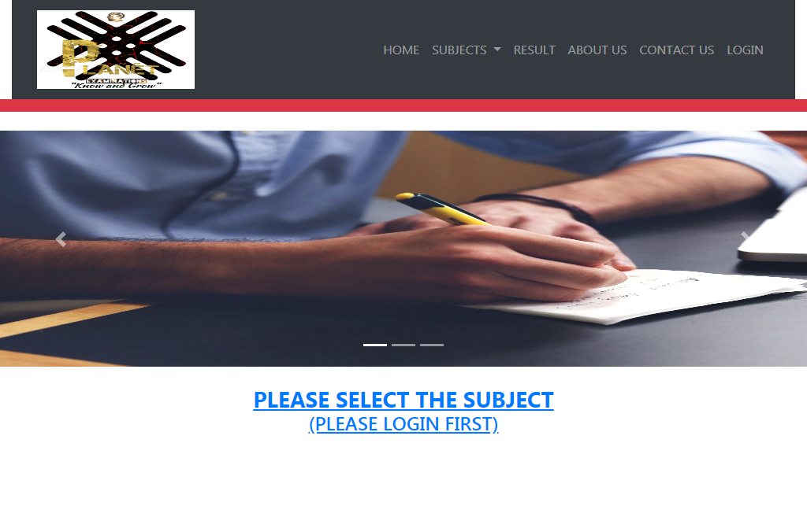 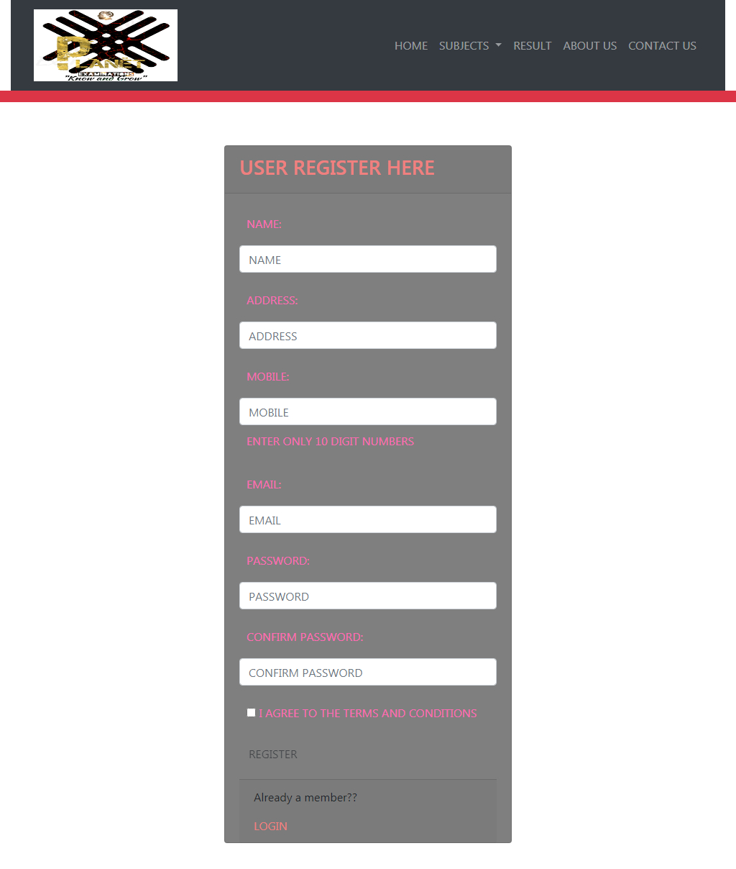 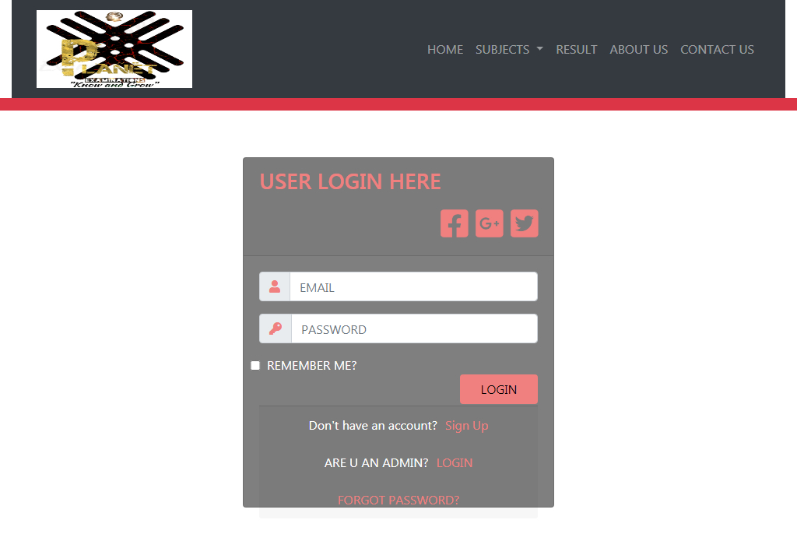

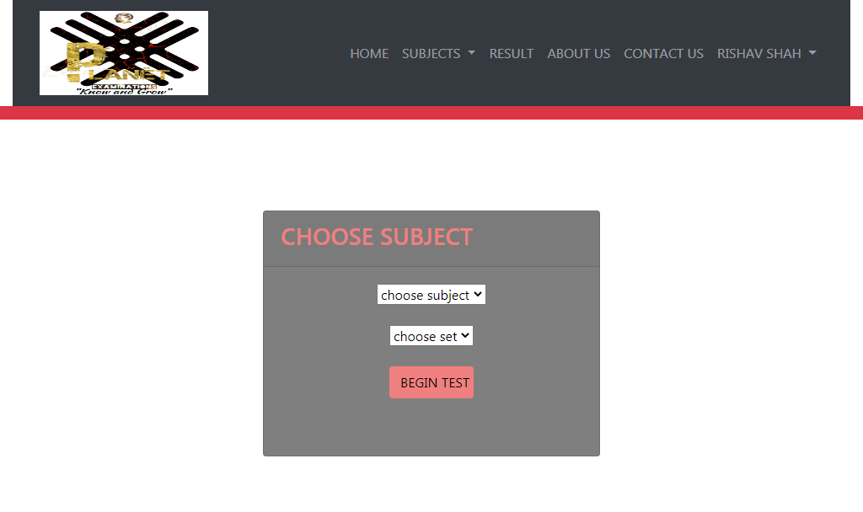

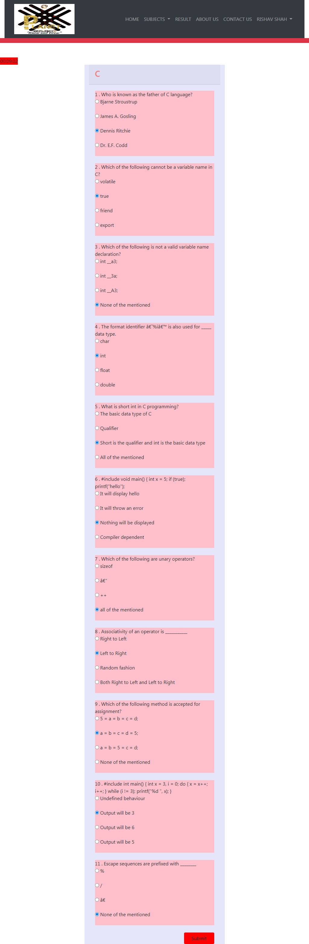

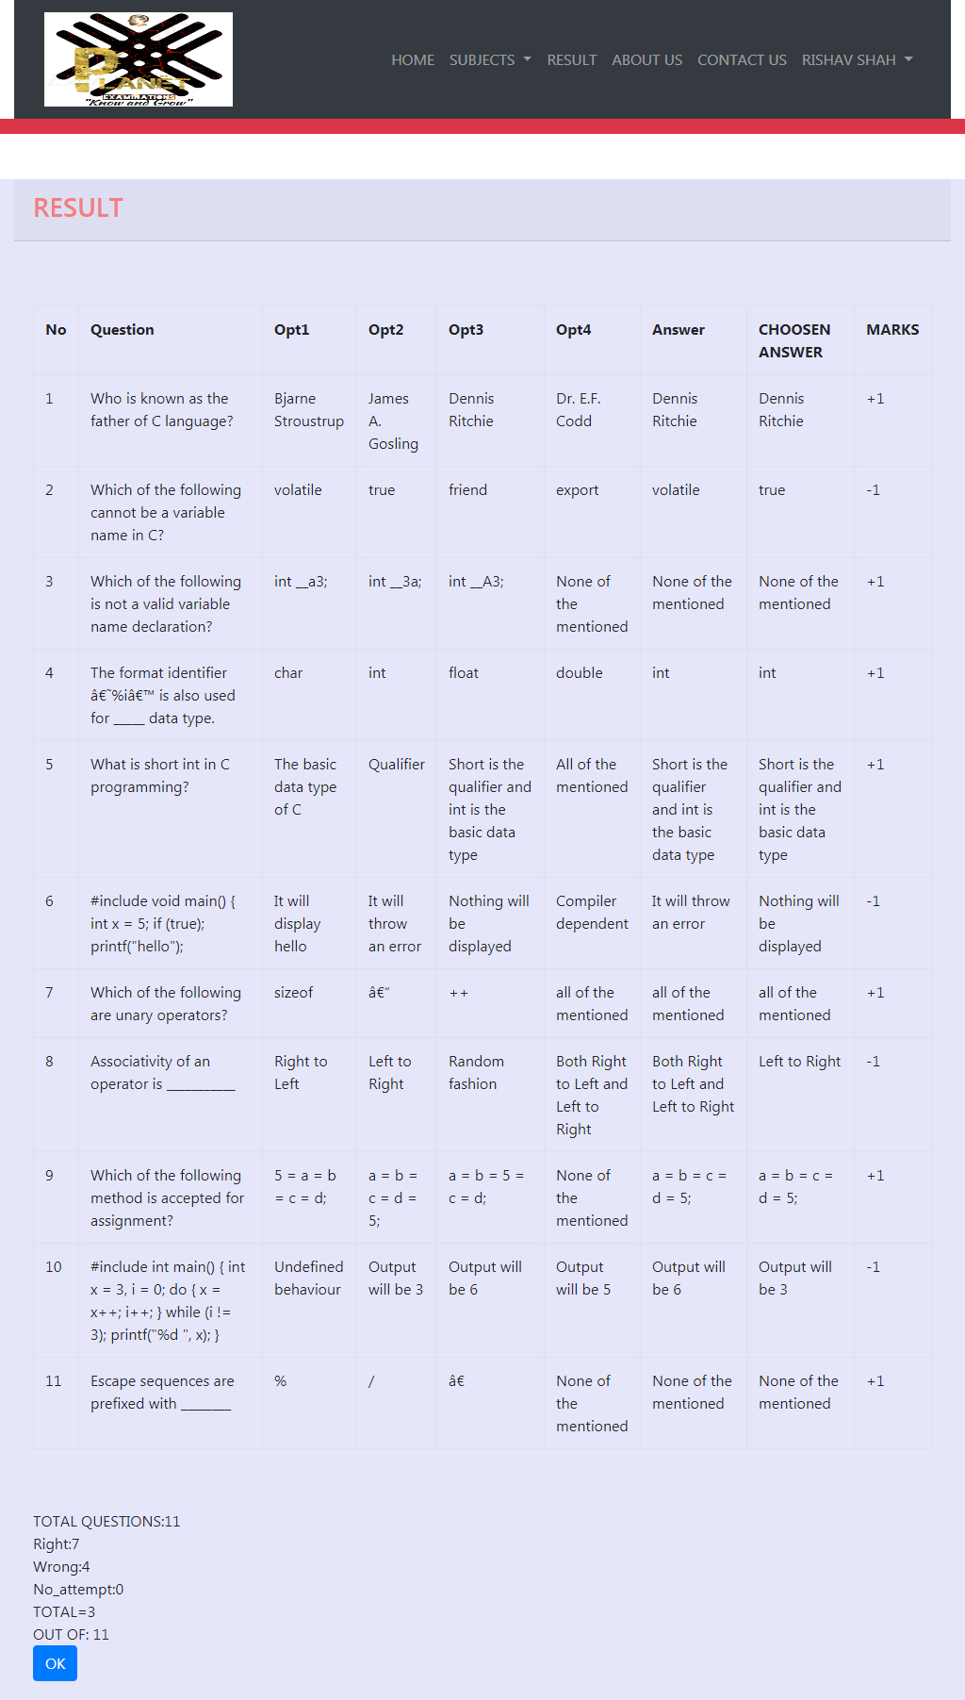

**Admin side:**

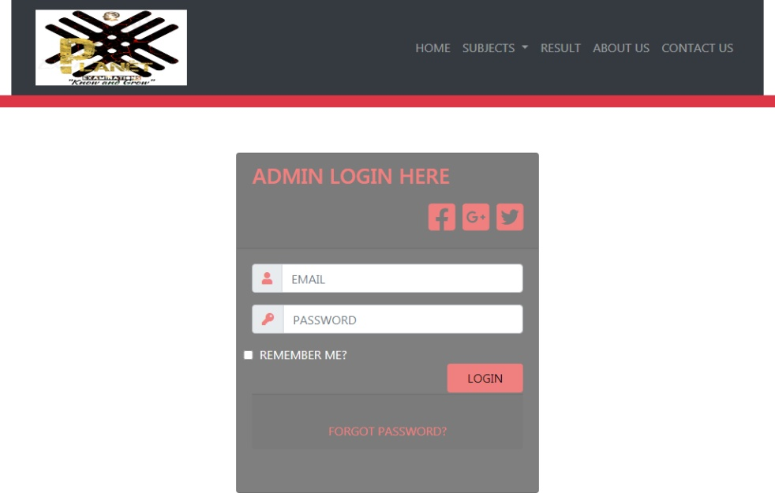

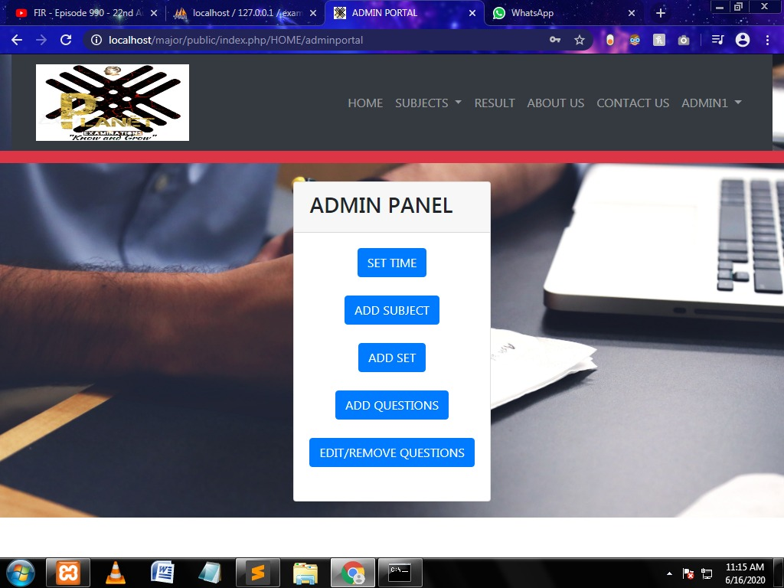

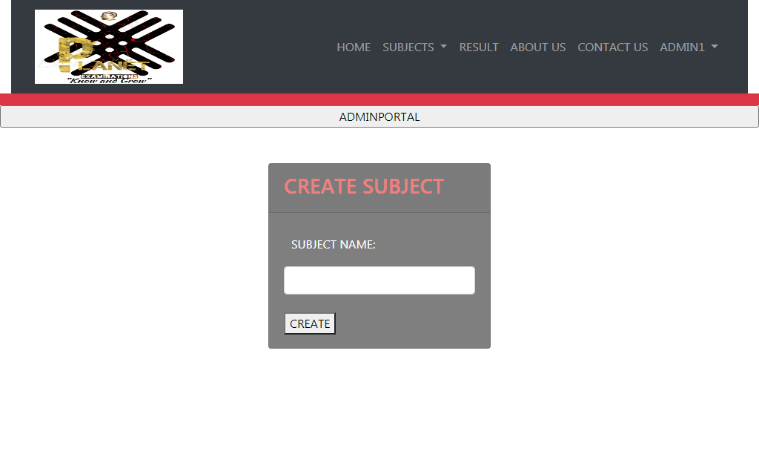

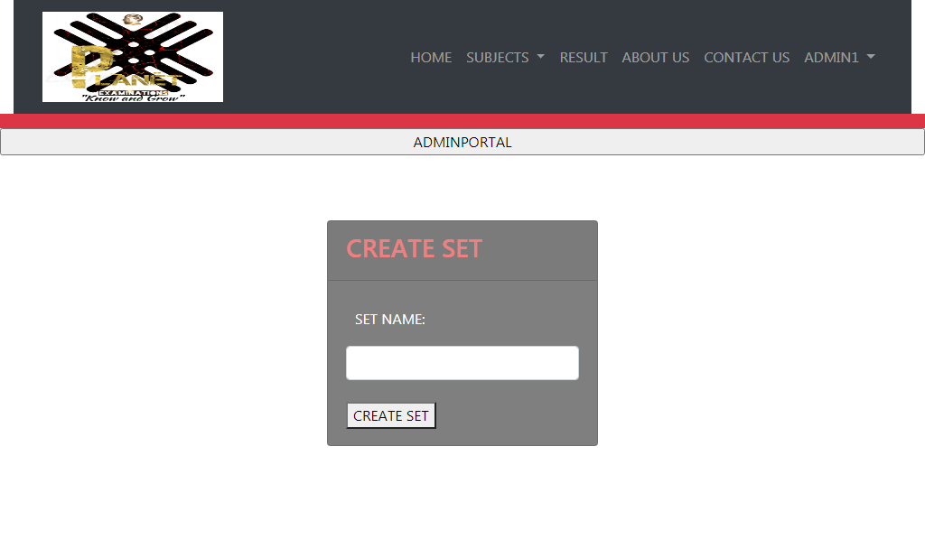

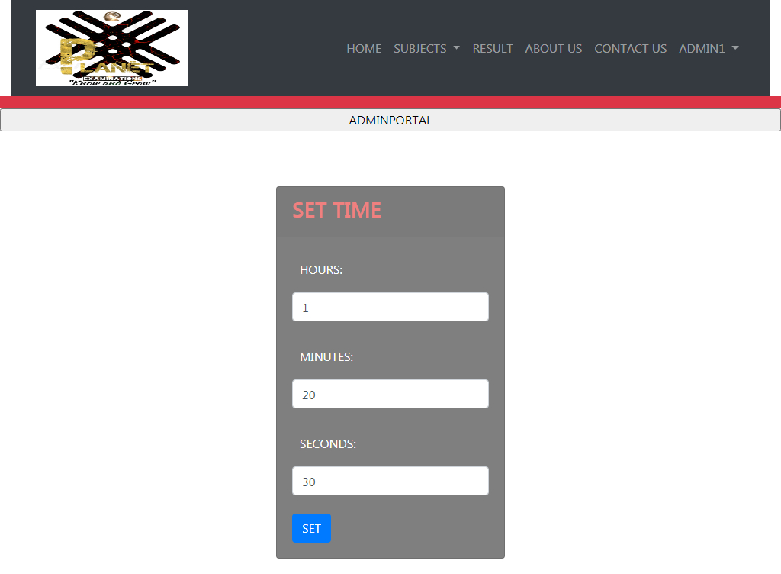

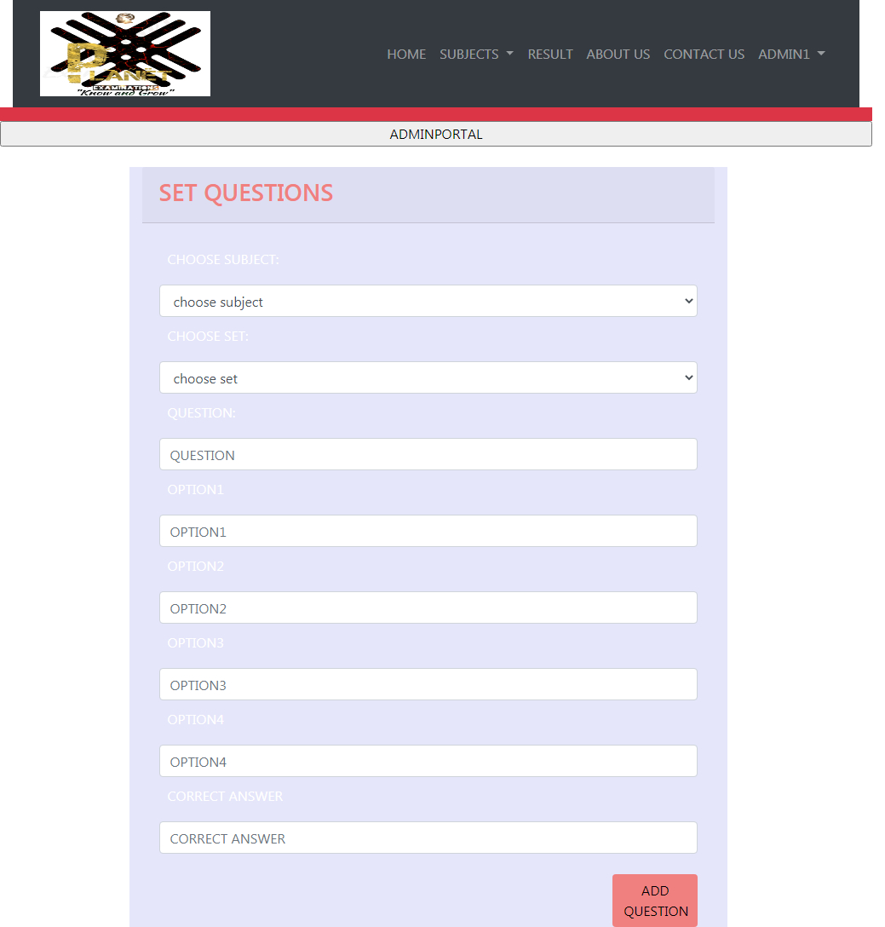

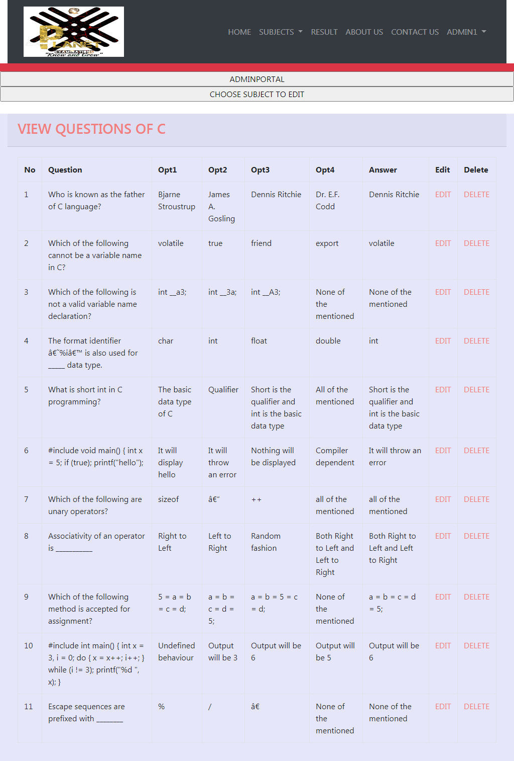

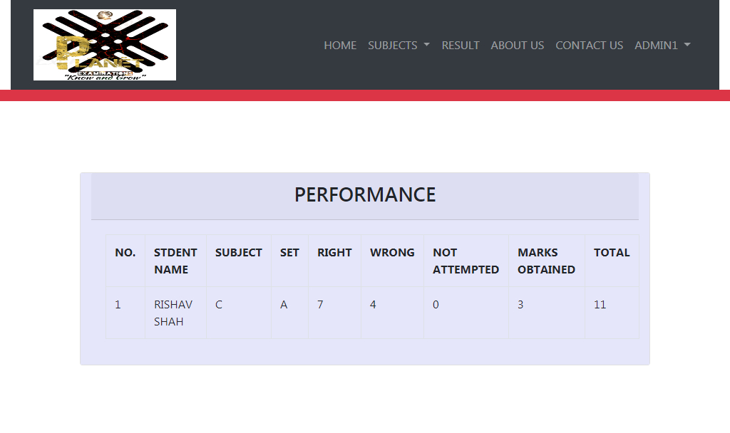

**7.Coding standards and assumptions**

* **Simple and easily understandable codes are used which are easy to debug and maintain.**
* **Proper indentation of codes for better understanding.**
* **Meaningful variables are used.**
* **Variables are named in camelCase.**
* **The codes are well commented to increase understandability.**



**8. Testing**

**Testing was done to determine the defects in our project.**

**Our project went through two levels of testing:**

1. **UNIT TESTING**
2. **INTEGRATION TESTING**

* **UNIT TESTING: The purpose of unit testing is to validate each unit of the software performs as designed. It is the first level of software testing where the individual modules are tested. This supports the fixing of defects at a earlier stage of development which is easier and less costly.**
* **INTEGRATION TESTING: Integration testing is performed after integrating the individual units. Here the individual units are combined and tested as a group. The main purpose of integrationtesting is to expose the faults or defects when the integrated units interact.**



**9. future scope of the project**

**The project has a very vast scope in future. We can provide more attractive features and update it as our requirement arrises, as it is very flexible in terms of expansion, for development following can be done:-**

* **We can give more advance programs in including more facilities like reminder of different examination.**
* **Including the mocks,lessons and notices whose pdf will be available the website.**
* **We will host the platform for online server to make it accessible worldwide.**
* **The website is not accessible to everyone. It can be deployed on a web server so that everyone can access it.**
* **As of now only 5 to 6 types of exams are available, in future more subjects with many concepts will be there.**
* **A feedback page will be provided in which user can post their reviews.**
* **Addition of valuable questions and various topics will also be added.**
* **We are also going to intake Governmental examinations in a year.**



**10. Conclusion**

**The website provides a online mode of a Examination, which enables the Students to give online test over internet which reduces much effort, money and travel. The Students can choose the exams by their own or given by respective companies or their schools and colleges. They can search for exams on some selective subjects to test their knowledge and efficiency; there is also a specific time limit to complete the examination to know about their own speed. The result of the exam is given then and there, thus making the process of examination much more hassle-free and easier.**



**11. Bibliography**

**11.1 WEB REFERENCES:**

* [**https://www.w3schools.com/js/default.asp**](https://www.w3schools.com/js/default.asp)
* [**https://www.w3schools.com/php/php_forms.asp**](https://www.w3schools.com/php/php_forms.asp)
* [**https://www.w3schools.com/bootstrap4/default.asp**](https://www.w3schools.com/bootstrap4/default.asp)
* [**https://www.w3schools.com/css/css_background.asp**](https://www.w3schools.com/css/css_background.asp)
* [**https://www.w3schools.com/sql/default.asp**](https://www.w3schools.com/sql/default.asp)
* [**https://www.google.com**](https://www.google.com)
* **https://www.getbootstrap.com**

**11.2 BOOK REFERENCES:**

# PHP and MySQL Web Development by[Luke Welling](https://www.amazon.in/Luke-Welling/e/B001IGHRRY/ref=dp_byline_cont_book_1)  and [Laura Thomson](https://www.amazon.in/Laura-Thomson/e/B001IGJV0A/ref=dp_byline_cont_book_2) .

# HTML and CSS: Design and Build Websites

**by**[**Jon Duckett**](https://www.amazon.in/Jon-Duckett/e/B001IR3Q7I/ref=dp_byline_cont_book_1)**.**

**Thank you....**